Year 6 Morse Code Workshops – Monday 14th of November and 21st of November

Annwyl Rieni/Gwarchodwyr,
Dear Parents/Carers,

On Monday 14th November ( J11+ J12) and Monday 21st of November (J10) will be taking part in workshops with NatureQuest Academy in our school outdoor areas based on the ‘ Morse Code’ . Please could the children bring into school suitable old/outdoor clothes and shoes/wellies to change into for this workshop?

As part of the workshop, the children will be making s’mores on the fire. They will be using chocolate digestives and marshmallows, the ingredients are below.
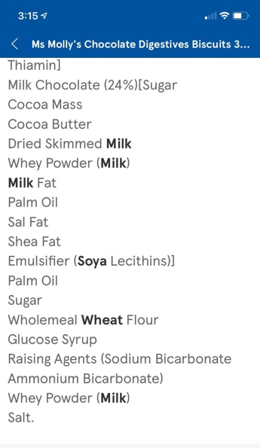
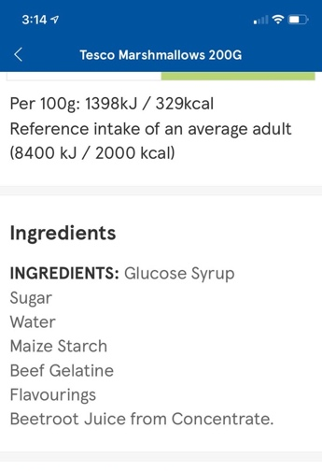
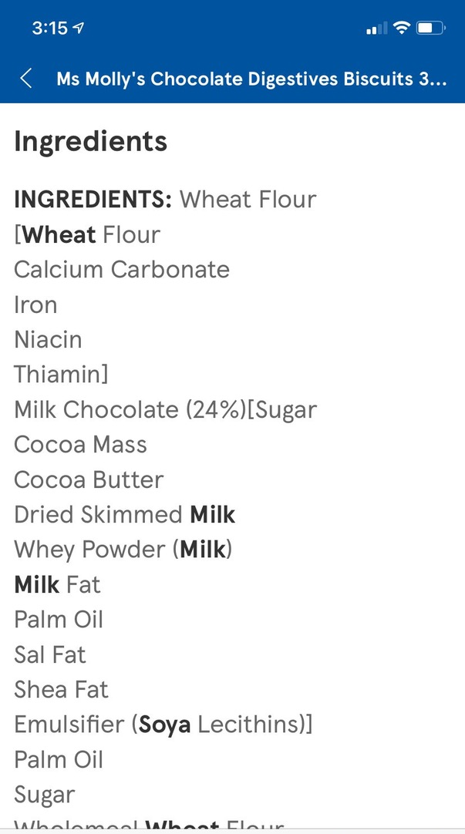

PTO
Please can you read these carefully before completing the slip below to give permission accordingly for your child to make and eat the s’mores. We are unable to allow the children to eat the smores unless we have received the completed permission slip from you.
Yours sincerely,

Year 6 Teachers

Please tick one box.
I give permission for my child _______________________________ to eat the s’mores as part of ‘The Morse Code’ workshop.

I do not give permission for my child __________________________ to eat the s’mores.

Signed: ________________________________

