Llangewydd Junior School – Ysgol Iau Llangewydd
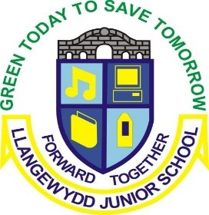
Sunshine & Rainbow - What will we be learning about this term?
Our topic this half term is ‘Dragons & Castles’. We hope to cover as much of the content, skills and experiences shown below as possible but this may change as Pupil Voice leads our learning into other areas.

Science and Technology
Mathematics and Numeracy
Languages, Literacy and Communication
- Sea Pollution and Amazon Rainforest
- Electricity – make a circuit
- Build a ‘tardis’ with lights
- Make various foods from different countries
- Fairy Bread

- DCF –
- Use Greenscreen to provide a voice over for where Spark is reporting from
- Powerpoint research into a chosen country
- Time, time zones, chronology
- Money
- Data collection on modes of transport to get to different countries
- Understanding and comparing temperatures
- Measure – Measuring the distance between cities etc
- Discussion on likes and dislikes of different countries/periods
- Make a travel information brochure on a country
- Research famous travellers – such as Neil Armstrong, James Cook, Francisco Pizarro
- Listen to and read a range of stories about other countries
- Perform a poem and song to peers - Eisteddfod
- Welsh – Read Tedi Twt books

Our Four Purposes inform all our learning:
- ambitious, capable learners
- enterprising, creative contributors
- ethical, informed citizens
- healthy, confident individuals

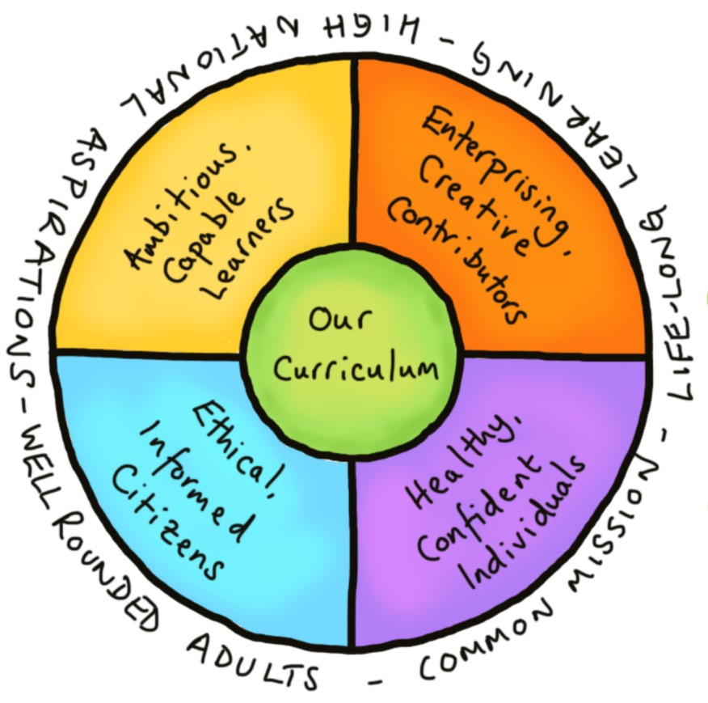
Cross-curricular Responsibilities inform all our learning:
Literacy, Numeracy and
Digital Competency
Spring Term 2 2026
Sunshine & Rainbow
Toy Time Travel

Health and Well-being
Humanities
Expressive Arts
- Resolving problems – Should we swim in the Barrier Reef
- Staying safe with electricity
- RVE – Christianity -Easter Story,
Ramadan
- Outdoor activities – Making food from other countries on a fire.

- Plan a journey
- Comparing past and present toys
- Comparing countries – climate, size etc
- Research & create a travel log on a country
- Map work to locate countiries and features
- Features and landmarks of different countries – Ayres Rock, Machu Picchu, Andes
- Learn a dance from another country
- Use instruments to accompany dance
- Aboriginal Art/Preuvian line textile
- Dress a toy in National costume
- Design and build a ‘tardis’ fit to take you into the future


- Listen to your child reading regularly for short, sharp periods of time (avoid making reading a chore) – their Bug Club book but also real-life texts e.g. menus, leaflets, adverts…
- Support your child with any homework tasks set by their teacher.
- Help your child to learn their times tables – Revisit the x2, x5 and x10 times tables but also learn their target times table.
- Encourage your child to use at home any of the interventions they use at school i.e. Lexia (some children), Reading Eggs , Mathseeds (some children) and Mathletics (some children).
- Join/visit your local library.
- Discuss the time in your everyday lives on analogue and digital clocks.
- Ensure that your child does activities that support their well-being e.g. eating well, sleeping well, resting well.
- Spend quality time with your child simply talking to them, enjoying family experiences, playing games…

- Let us know what they would like to learn about within the topic.
- Complete any homework tasks set by their teacher.
- Bring into school any interesting items linked to our topic.
- Read regularly – their Bug Club book, real-life texts e.g. menus, leaflets, adverts…
- Practise their times tables – Revisit the x2, x5 and x10 times tables but also learn their target times table.
- Spend some time at home using any of the interventions they use at school i.e. Lexia, Reading Eggs and Mathletics (some children)or Mathseeds(some children).
- Practise handwriting – letter and number formation.
- Spend time outside playing.
- Do activities that support their well-being e.g. eat well, sleep well, rest well.
What can I do to support my child’s learning?
What my child can do:
A celebration of the work we have participated in during the term posted on Seesaw.

Mad Science

Our Fabulous Finish celebration event:
Visitors and Visits:

