Teaching and Learning Policy

Date | Review Date | Co-ordinator | Nominated Governor
January 2026 | January 2027 | Mr. Darryl Evans | AOLE Leads

United Nations Convention on the Rights of the Child
At Llangewydd Junior School, we put the United Nations Convention on the Rights of the Child (UNCRC) at the heart of our school’s planning, policies, practice and ethos. We are a Rights-Respecting School and teach about children’s rights - modelling rights and respect in all our relationships: between teachers/adults and our learners.
The UNCRC underpins our school vision and aims. We encourage our children to:
- listen to others and respect their ideas.
- learn about their rights, respect the rights of others and to inform others of children’s rights.

Introduction

This Teaching and Learning policy provides a framework for the highest quality teaching and learning and is shaped by our commitment to enabling all our learners to achieve the highest academic and personal standards of which they are capable. Through aspirational, reflective teaching and learning informed by key pedagogical principles, we aim to engage, enthuse and inspire our learners, co-constructing with them a broad and balanced curriculum that enables them to realise the four purposes and equips them for ongoing learning, work and life. As reflective practitioners committed to implementing Curriculum for Wales, new approaches and pedagogy, we are continually using our own learning to evaluate and refine our approach to teaching and learning. As we implement Curriculum for Wales, pedagogy is paramount within our school setting:
- Collaboration allows effective pedagogy to spread within our school.
- Innovation moves pedagogy forward.
- Professional Learning deepens effective pedagogy.
- Leadership creates a culture and climate in which pedagogy can grow.
At Llangewydd Junior School, as lifelong learners, we believe that teaching and learning should be positive and inspiring experiences for us all with well-being and enjoyment at their core. Through our teaching, we equip our learners with the skills, knowledge and understanding necessary to be able to make informed choices about the important things in their lives. By placing an emphasis on Pupil Voice, we empower our children to make decisions about their own learning pathways and enable them to drive their own tailor-made curriculum.
We work hard to ensure that all learners experience the highest quality teaching and learning during their time at Llangewydd Junior School, offering a broad and balanced curriculum that promotes learners’ spiritual, moral, social, cultural, mental and physical development and relates to local, national and global contexts. Using the experience, enthusiasm and expertise of staff, we provide engaging and inspiring teaching and learning experiences that are differentiated appropriately to meet children’s individual needs and abilities in inclusive classroom and outdoor environments.

Aims
At our school, we aspire to secure teaching and learning that:
- enables our learners to realise the four purposes and equips them for ongoing learning, work and life.
- engages our learners in holistic, cross-curricular, topic-based learning that promotes an enjoyment of learning.
- is ambitious, promoting high expectations and enabling all learners to achieve their full potential.
- is inclusive: easily understood by all, encompassing an entitlement to high-quality education for every child, and taking account of their views in the context of the UNCRC.
- offers a broad and balanced education that enables our learners to make links between the different areas of learning and experience and to apply their learning to new situations and contexts.
- supports progression along a continuum of learning, equipping our young people with the knowledge, skills and experiences for future challenges as lifelong learners.
- supports learners’ health and wellbeing.
- supports learners’ development of the knowledge, skills and experiences that are the foundation of being an informed citizen.
- is authentic, recognising our learners’ identity, language(s), ability and background and the different support they may need given their particular circumstances.
- is evidence-based, drawing on the best of sound research and existing practice both within and beyond Wales.
- is responsive – relevant to the needs of today (individual, local, national and global).
- reflects the diversity of perspectives, values and identities that shape our learners’ locality and Wales, as well as develops an understanding of the wider world.
- is shaped by Pupil Voice, co-constructed and responsive to learners, their families and the wider community.
- enables our learners to make sense of growing up in contemporary Wales and of issues that will be important into the future, including well-being, sustainable development and citizenship.
- enables our learners to develop an understanding of their rights and the rights of others.
- is based on subsidiarity: commanding the confidence of all whilst encouraging appropriate ownership and decision-making by those closest to the teaching and learning process in specific contexts.

Our Pedagogical Principles
‘A bad curriculum well taught is invariably a better experience for students than a good curriculum badly taught: pedagogy trumps curriculum. Or more precisely, pedagogy is curriculum, because what matters is how things are taught, rather than what is taught.’
Dylan Wiliam, Embedded Formative Assessment
At Llangewydd Junior School, we view pedagogy as the considered selection of teaching methods used in light of the purposes of the curriculum and the needs and developmental stage of our learners. It combines theoretical and practical knowledge and skills with fine judgement about what is required to promote effective learning in particular contexts. Our teachers have a sound understanding of the ‘why’ and ‘how’ of teaching as well as the ‘what’. Indeed such carefully considered pedagogy lies at the heart of what it means to be an excellent teacher at our school.
The elements of excellent teaching include in various ways: subject and methodological expertise; sound classroom craft skills; an understanding of the social and psychological factors that influence learning; and the ability to excite and inspire children to want to learn and to be able to learn independently. Our teaching and learning policy does not place an emphasis on any particular teaching approaches. Instead we acknowledge that decisions about teaching and learning are very context and purpose specific, and are best taken by our teachers and classroom support staff themselves. However, teaching and learning at our school is shaped by a number of pedagogical principles (See Appendix 1) that relate directly to the purposes of our curriculum and our assessment arrangements:
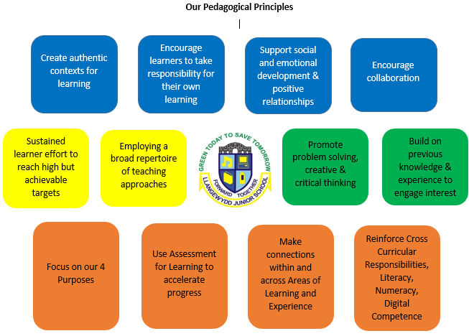

These pedagogical principles inform our teaching and learning, and permeate our curriculum. We believe that effective teaching and learning at our school:
- focuses on the four purposes of the curriculum.
The balance of experiences offered to our learners and our selection of teaching and learning approaches is regularly reviewed in relation to our four over-arching curriculum purposes.

- challenges all learners by encouraging them to recognise the importance of sustained effort in meeting expectations that are high but achievable for them.
Teaching and learning at our school sets expectations that challenge our learners to have high personal aspirations and achievement. Our teaching proceeds on optimistic assumptions about its ability to make a positive difference in ways that will encourage such high aspirations in all learners. We do not endorse self-limiting beliefs about fixed potential, talent, ability or intelligence, acknowledging that these can have a profoundly negative effect on learning. Instead, our consistent message is that sustained effort is integral to effective learning and can lead to high achievement. At our school, we do, of course, praise and support children’s efforts at learning but also create opportunities for our learners to make and learn from errors in the pursuit of challenging goals, recognising that this can build confidence and resilience. We understand the importance of adopting teaching approaches that engage learners’ interest in relation to goals that they perceive as worthwhile in releasing additional discretionary effort and a ‘can do’ attitude. Our teachers aim to nurture in our children the intrinsic satisfaction that comes from making the effort to address and succeed with challenging tasks. In this way, lifelong learning can become a matter of personal fulfilment as opposed to one-off responses to external demands. All young people will encounter difficulties with learning of one kind or another at different points in their school careers. We recognize the importance of identifying and addressing such difficulties early before they become entrenched. Early intervention is therefore an integral part of our teaching and learning.

- means employing a broad repertoire of teaching approaches including direct teaching.
In shaping our curriculum, we do not place an emphasis on any particular teaching approach, understanding that decisions about teaching and learning are very context and purpose specific, and are best taken by our teachers themselves. Teaching and classroom support staff use different teaching styles including ‘direct teaching’ and inquiry-based/discovery learning or constructivism. Through the sharing of clear purposes and success criteria, modelling and practice, and regular and insightful feedback, direct teaching involves the active engagement of the teacher in ‘scaffolding’ learning. Creating contexts within which learners can demonstrate the ability to apply learning independently in unfamiliar settings is an important part of that scaffolding. We blend different teaching approaches to suit the ability and learning styles of our learners in a wide variety of teaching and learning contexts. We:
assess the impact of the teaching approach through pupil progress.
match their needs to the most appropriate pedagogical approach.
identify our learners’ greatest needs

repeat

- promotes problem solving, creative and critical thinking.
Pedagogy at our school places an emphasis on making full use of wider skills within and across each Area of Learning and Experience, particularly problem solving, creative and critical thinking. This is likely to activate powerful learning for our children, developing their ability to critically evaluate information, make connections, develop deep conceptual understanding and transfer knowledge and skills to new situations to solve complex problems in creative ways. Effective teaching at our school reinforces and extends the application of wider skills as our teachers identify activities and strategies that promote problem solving, critical and creative thinking. These processes are monitored and assessed to ensure positive learning outcomes.

- sets tasks and selects resources that build on previous knowledge and experience and engage interest.
We acknowledge that our learners arrive at school with different aspirations, interests and experiences and so will approach learning in different ways. A one-size-fits-all approach to learning will not meet this range of needs. At the same time, however, we are careful not to assume too much about our ability to identify such needs and are acutely aware of the danger of separating children into potentially superficial groupings. Progression throughout our school provides a context within which our teachers can select teaching and learning approaches that build from one step to the next but that still provide significant freedom to offer engaging experiences that match our learners’ needs.

- creates authentic contexts for learning.
At Llangewydd, we are committed to making learning meaningful and authentic, reaching out to and responding to the world beyond our immediate setting. We believe that it is important that our young people see the relevance of their learning to the world beyond the school gates and hence we actively create opportunities to forge links to that world. We recognise, for example, the need to go beyond our own expertise and are always open to developing links with outside bodies and individuals. Visits and visitors play a significant part in helping to bring abstract learning to life. Similarly, the internet opens up immense possibilities to access resources, explore sources and engage with real-life issues. We also value performance in its widest sense for its contribution to creating authenticity. Leadership skills, for example, are fostered in classroom roles as well as through more informal participation in clubs and extra-curricular activities. The application of learning is demonstrated in talks, debates, Fabulous Finish showcases, plays, choirs, Pupil Voice Committee meetings and so on – whatever form can best bring out the application of what has been learned in ways that are appropriate and uncontrived.

- uses Assessment for Learning principles to promote learner progress.
Assessment for Learning is an integral, inseparable part of good teaching and learning at our school; as relevant to teaching and learning as it is to assessment. Our Assessment for Learning approach provides our teachers and classroom support staff with insight into the effectiveness of teaching and learning and involves providing regular and meaningful feedback to learners as well as adapting teaching and materials to meet their needs. It also helps our learners improve their standards and nurture ambition: learning can be particularly powerful when our learners are given constructive feedback that helps them think through issues and provides them with guidance regarding next steps in their learning. Similarly, we regularly create opportunities for self- and peer- assessment which can provide a safe environment to articulate and test ideas, leading to our learners assimilating SMART targets that they can focus on in order to make further progress.

- makes connections within and across Areas of Learning and Experience.
In a rapidly changing world, one of the defining features of twenty-first century education will be the capacity to make connections and transfer knowledge and understanding across different contexts in order to address unfamiliar problems. At our school, we do not view the Areas of Learning and Experience as distinct entities or timetabled, discrete subject areas, nor do we develop literacy, numeracy or digital competence in isolation. Instead we promote connections, unity and fluidity within and between the Areas of Learning and Experience in order to improve and reinforce learning in the constituent disciplines. We explore pedagogical approaches that allow connections to be made through common questions, concepts or skills within and across Areas of Learning and Experience.

- regularly reinforces Cross-curriculum Responsibilities, including literacy, numeracy and digital competence, and provides opportunities to practise them.
We aim to embed the Cross-curriculum Responsibilities of literacy, numeracy and digital competence, together with the wider skills, in the Areas of Learning and Experience. They are applied as an authentic, integral part of the teaching and learning process at our school.

- encourages learners to take increasing responsibility for their own learning.
Our curriculum purposes emphasize the need to develop the confidence and capacity to learn throughout life. The development of such capacities is strongly influenced by how our children are taught. We are committed to involving our learners in planning their own learning through discussions about what they have achieved and how they can best be supported to achieve future aspirations. At our school, we acknowledge the impact that metacognition, or ‘learning to learn’, can have in helping our learners to take greater control of their own learning. Metacognition involves the knowledge that an individual has about the way they and other people think, and knowing when and how to apply skills/strategies to support learning in different situations. It also involves the ability to think strategically and use a structure to achieve a goal or solve a problem. In order to become capable lifelong learners, we encourage our children to stand back and observe their own process of learning, and to identify how it can be improved. Working with their teachers and peers helps our learners to hone their metacognitive skills because collaboration provides them with opportunities to talk about their thinking processes, compare them with others and refine their learning skills as a result. We understand the importance of making our learners active participants in the learning process with an understanding of how to learn and how to create the best conditions for their own learning.
Some learners will require more support, more examples, more practice and so on, but it remains important that, wherever possible, they take responsibility for their own learning and set themselves ambitious goals. At Llangewydd, the essence of personalised learning lies in interactions between our teachers and children and between the children themselves. Such interactions are characterised by a flexibility in approach and a responsiveness to emerging needs.

- supports social and emotional development and positive relationships.
At our school, we recognize that learning is not a purely cognitive activity and understand that we need to be aware of and responsive to our children’s emotions and motivations if successful learning is to take place. Our teaching and learning functions within the parameters of our children needing to feel competent to do what is expected of them and learning better when they experience positive emotions. We pursue a pedagogy that supports social and emotional aspects of learning across every aspect of the curriculum and is integral to our curriculum purposes. Indeed we understand that the climate for learning is part of the learning experience. In supporting our learners’ social and emotional well-being, we provide opportunities for the development of emotional intelligence and metacognition. Our learners can thus reflect on their own learning and understand the positive impact that they might have on the learning of others.

- encourages collaboration.
Teaching and learning at our school creates structured opportunities for co-operative learning and collaboration between learners to take place constructively. We view our classrooms as strong communities – places where our learners interact with and support each other when they need help to overcome challenges in different contexts. An emphasis on collaborative learning highlights the positive effects of peer learning on motivation, problem solving and achievement. It is also a response to employers regularly citing the ability to function effectively as a member of a team as one of the key skills necessary in the modern workplace.
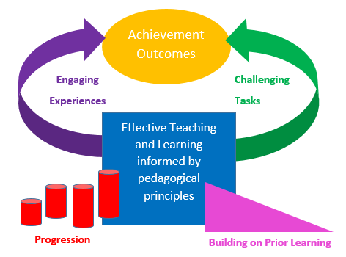

Effective Teaching
We believe that the following represent effective teaching at Llangewydd Junior School (See Appendix 4).
BEFORE lessons, our teachers will:

- use assessment information (AfL and AoL) and an evaluation of prior learning to inform planning of current lessons.
- ensure that they have good subject knowledge.
- have a good knowledge about how children learn.
- respond to Pupil Voice input, planning teaching and learning opportunities where learners can make personal choices and follow their interests in curriculum activities.
- plan and resource lessons that:
- build on previous knowledge and experience to engage the learners’ interest.
- focus on our four purposes.
- have a clear learning objective with a narrow focus.
- create authentic contexts for learning.
- place an emphasis on the teacher as a facilitator (not a preacher).
- promote pupil engagement and accountability throughout.
- achieve an appropriate balance between teacher talk and pupil talk/engagement.
- prioritize higher order questioning e.g. inferential, evaluative and appreciative questions (See Appendix 2 and 3)
- are punctuated by a continuous spiralling of short, sharp ‘pit-stop plenaries’ which focus on checking understanding, reinforcing, clarifying, refining and extending teaching and learning points.
- our learners will enjoy – the ‘fun’ factor.
- require sustained learner effort to reach high but achievable targets.
- select the most effective teaching approaches for the specific context and purpose of the lesson.
- make connections within and across AoLEs.
- reinforce cross-curricular responsibilities – literacy, numeracy and digital competence.
- promote problem solving, creative and critical thinking.
- support learners‘ social and emotional development, and positive relationships.
- encourage collaboration.
- provide first-hand experiential learning.
- encourage learners to take responsibility for their own learning, considering what their next steps should be – what they need to achieve and how they will achieve it.
- use Assessment for Learning to accelerate progress.
- provide a stimulating, well-organised learning environment (both indoors and outdoors) with resources easily accessible to our learners.

DURING lessons, our teachers will:
(See Appendix 4 – Our Lesson Map)
- revisit prior learning (if it links to the learning objective) and build upon it. They will also create opportunities for our learners to revisit prior learning, and to respond to and act upon feedback given.
- facilitate recaps that can be teacher- or pupil-led. These may focus on knowledge content and/or skills. Our recaps give ‘no opt-out’ for children and are elicited from them e.g. mini-whiteboard work, Silent Solo, Turn and Talk, Think:Pair:Share, Post-Its, Cold Call questioning, Pose: pause: pounce: bounce.
- have high expectations of learners.
- maintain good pace, using time effectively to sustain learners’ engagement, on-task behaviour and progress whilst at the same time allowing appropriate time for learners to achieve quality outcomes.
- share and explain clear learning objectives (our WALTS) relevant to our four purposes. We share one planned learning objective with a narrow focus which can be reviewed throughout a lesson. Our learning objective is not written in learners’ books.
- have clear, differentiated quality criteria; our ‘Quality Qs’ – what is needed to secure quality outcomes. These are the planned-for skills the learners will use to achieve the learning objective. We create opportunities for our learners to negotiate, initiate and create their own quality criteria.
- ensure that lessons have an inspiring, engaging introduction to set the scene for learning and ‘hook’ the learners.
- use a variety of teaching styles and strategies to actively engage our children including direct teaching and inquiry-based or discovery learning.
- facilitate learning and maximum pupil engagement/accountability through:
- APPEARING – to focus the learning, elicit short recaps, set a task, reinforce, clarify and extend teaching and learning points.
- DISAPPEARING – to work alongside learners: questioning, checking understanding, reinforcing, rearticulating, adjusting, extending…
- CHALLENGING – holding our learners to account e.g. ‘Can you….? I will back in two minutes to see if you have….’
- SCANNING the learning environment to assess where teacher intervention is most needed.
- REPEATING the above.
- effective questioning based on the Q Matrix (See Appendix 2) with a commitment to posing higher order questions and allowing ‘Thinking Time’.
- prioritizing higher order inferential, evaluative and appreciative questions and avoiding closed questions.
- providing clear explanations and instructions.
- intervening effectively and sensitively.
- sometimes delaying teacher intervention to allow opportunites for our learners to make mistakes and to learn from them.
- providing ambitious models/exemplars of anticipated outcomes as well as anti-models to highlight an absence of quality criteria.
- explicit and incidental teaching of vocabulary.
- adapt and redirect teaching and learning opportunities in response to real-time Pupil Voice input where learners make personal choices and express preferences according to their interests.
- implement appropriate and challenging activities where, through sustained effort, learners can achieve targets. We recognize that if our learners are being genuinely challenged, they will make mistakes. Our learners are allowed to ‘get it wrong’ as it is through making mistakes that they will learn.
- create opportunities for independent work, paired work, group work and whole class work.
- implement a range of experiences over time including outdoor learning, fieldwork and visits to places of educational interest.
- differentiate effectively ‘from the top down’ so that all our learners are challenged and supported in their learning in order to achieve maximum educational and personal benefit. Our methods of differentiation include differentiation:

- by task.
- by grouping.
- by resource.
- by support.
- by questioning.
- by assessment and feedback.
- by teaching style.
- facilitate a regular review of learning and a consideration of next steps in the context of a continuous, spiralling of ‘pit-stop plenaries’ throughout and at the end of lessons. These are not implemented for the whole class all of the time. They can be directed at small groups. Our ‘pit-stop plenaries’ may focus on checking understanding, reinforcing, clarifying, rearticulating or extending teaching and learning points.
- ensure that there is a balance between child-initiated and teacher-led learning.
- manage classroom support staff effectively to secure the best possible outcomes for our learners.
- promote the development of skills across the curriculum (literacy, numeracy, digital competence and problem solving, creative and critical thinking skills) and learning across the curriculum.
- use ICT to enhance their teaching.
- use positive language to motivate and engage our learners.
- use a variety of strategies to promote learners’ positive, on-task behaviour and self-discipline within a supportive classroom community where learners collaborate and support each other in order to overcome challenges.
- be well-organised, selecting and using a range of appropriate resources and groupings.
- assess learning regularly (AfL and AoL), providing regular and meaningful feedback to learners as well as adapting teaching and materials to meet their needs. Throughout lessons, constructive, formative feedback will guide our learners regarding next steps in their learning.
- facilitate ‘Reflection Time’ where our learners are given time to read, act on and respond to teacher feedback.
- create opportunities for learners’ self- and peer- assessment. Our learners are invested with ownership of their own learning, being encouraged to articulate and assimilate SMART targets that they can focus on in order to make further progress.
- use metacognitive language to help our learners to hone their metacognitive skills by providing them with opportunities to talk about their thinking processes, compare them with others and refine their learning skills as a result.
- be flexible, adaptable and responsive to learners’ progress and behaviours throughout lessons. Teachers at our school are reactive - ready to change a lesson’s objective, focus or teaching approach in response to the needs of different groups of learners.
- be role models in their personal literacy skills and use of language.
- promote multilingualism through incidental use of Welsh and BSL throughout lessons (e.g. instructions and the signalling of transitions throughout the school day) as well as some subject-specific Welsh and BSL appropriate to learners’ age and ability used within topic-based teaching.
- create a positive classroom climate and culture where good relationships and well-being are championed. Our classrooms reflect our school values, promoting kindness, respect and tolerance in all relationships.
- model a ‘can do’, positive mindset in order to promote constructive, aspirational attitudes to learning.
- treat all learners equally irrespective of race, gender or disability.

AFTER lessons, our teachers will:

- critically reflect upon and evaluate lesson outcomes. What worked well? What could have been improved? What are my areas for development? What are the implications for my professional learning?
- mark and respond to pupils’ work, giving feedback in accordance with our Assessment and Feedback Policy.
- monitor and review learners’ progress. Who achieved the learning objective? Who is working above, at or below expected levels? What are the SMART targets or next steps in their learning? Who is ready to move on? How will the teacher move them on? What interventions are needed? Does the teacher need to re-teach something in a different way? In what way will they do this?
- involve or report to parents, keeping them informed of pupil progress.
- use assessment information (AfL and AoL) and an evaluation of learning to inform planning of future lessons.
- plan new teaching and learning opportunities in response to Pupil Voice input where learners have expressed preferences according to their interests.
(See Appendix 7 – Pupil Entitlement – Teaching and Learning)

Effective Learning
We believe that quality learning is reflected in the outcomes of the teaching experienced by our children and that this is evident in their responses, attainment and progress. Research about how to maximise learning informs our pedagogy. We use experiential tasks and challenges to encourage independent learning. High quality learning is achieved at Llangewydd Junior School when our children:
- are engaged, showing high levels of interest and motivation.
- are accountable and given ‘no opt-out’ e.g. there is an expectation that they will be able to recap previous learning, try to answer questions after being given thinking time, feedback to the teacher about challenges given…
- understand the learning objectives (our WALTs) and how they can achieve them (our Q – what makes a quality outcome).
- produce quality work.
- explore and experiment in first-hand experiences.
- talk confidently, ask and answer appropriate questions.
- contribute ideas and value the ideas of others.
- challenge ideas in an appropriate way.
- are attentive and focused.
- are developing positive attitudes in order to become resilient learners, have a willingness to learn, and are gaining in confidence.
- demonstrate independence.
- build on prior knowledge and experiences.
- take ownership of their own learning by setting their own SMART targets and responding to targets set.
- are aware of what they need to do to improve – what they need to do next and how they will do it.
- are able to talk about how they learn.
- communicate effectively.
- respond to opportunities to solve problems and use creative or critical thinking skills.
- experience success but also make mistakes by being appropriately challenged.
- make decisions, take risks and learn from their ‘marvellous mistakes’.
- co-operate and collaborate in a range of contexts with different purposes, fulfilling different roles.
- show kindness, respect and tolerance towards others.
- build good relationships with adults and each other.
- engage with others in the wider community.
- above all, enjoy learning.
(See Appendix 7 – Pupil Entitlement – Teaching and Learning)
A Good Lesson
A good lesson at Llangewydd Junior School may include many of the following features:
(See Appendix 4 - our Lesson Map)
- Recap of previous learning.

- a teacher- or learner-led recap of previous learning (if relevant to the current lesson’s learning objective).
- this often focuses on knowledge content or skills.
- briefly and efficiently revisiting and reinforcing previous knowledge, skills and understanding and relating it to current learning.
- our learners are engaged in this recap of previous learning and given ‘no opt-out’ e.g. Silent Solo, Turn and Talk, Think: Pair: Share, mini-whiteboard task, Post-Its, Cold Call questioning, Pose, Pause, Pounce and Bounce questioning technique…

- A short, sharp introduction - The purpose of our lesson introductions is to:

- ‘hook’ and engage our learners using a stimulating resource e.g. a picture, a film clip, an object, music, a game, a visitor, a challenge.
- share the learning objective of the lesson – our WALT, identifying a narrow focus/skill to be introduced, reinforced, revisited or applied in a different context.
- put the learning in an authentic context.
- implement a ‘warm up’ task. This will often be organised in small groups or pairs to reinforce previous knowledge or to introduce the new skill being taught.
- introduce a main challenge or focus for the lesson.
- share high expectations and challenge all learners.
3. The Main Activity/Activities – to include a continuous spiralling of ‘pit-stop plenaries’. This would be split into constituent parts so that the learning is varied, pacey and challenging. The purpose of this main activity would be to introduce new learning, reinforce or extend previous learning and may include:

- the teacher facilitating learning and maximum pupil engagement/accountability through:
- APPEARING – to focus the learning, elicit short recaps, set a task, reinforce, clarify and extend teaching and learning points.
- DISAPPEARING – to work alongside learners: questioning, checking understanding, reinforcing, rearticulating, adjusting, extending…
- CHALLENGING – holding our learners to account e.g. ‘Can you….? I will back in two minutes to see if you have….’
- SCANNING the learning environment to assess where teacher intervention is most needed.
- REPEATING the above.
- a regular review of learning and a consideration of next steps in the context of a continuous, spiralling of ‘pit-stop plenaries’. These are not implemented for the whole class all of the time. They can be directed at small groups. Our ‘pit-stop plenaries’ may focus on checking understanding, reinforcing, clarifying, rearticulating or extending teaching and learning points. We place an emphasis on ‘sample and example’.
- eliciting ideas from the children using effective, higher order questioning to find out what the children know and what they want to find out.
- explaining differentiated tasks (with challenge) which may be a combination of group, paired or individual tasks.
- regularly referring to the learning objective – our WALT.
- sharing, negotiating or creating our ‘Q’ – what we are looking for in a quality outcome.
- encouraging our learners to regularly refer to our ‘Q’ in order to self- and peer-assess their progress.
- sharing a model as a focus for discussion and analysis. Sharing pupil work as part of our ‘sample and example’ strategy.
- using our ‘Q’ to up-level a weak example of an outcome.
- using our ‘Q’ to develop a shared outcome.
- activities informed by our pedagogical principles that enable the children to use and apply their new learning, challenging every learner – AEL, OT, BEL, and ALN.
- sharing high expectations and challenging all learners.
4. Reflection and Pupil Influence. The purpose of this final part of the lesson is to:

- reinforce the learning objective, our WALT, and to recap on learning. We encourage every pupil to consider: What have I done? What have I learnt? What will my next steps be?
- review the WALT and our ‘Quality Qs’ (what makes for a quality outcome) to see if these have been achieved – what has/has not been achieved?
- look ahead to next steps in learning. What do learners think their next steps should be? How do they think they will achieve them?
- provide our learners with an opportunity to share and showcase their work. Sample and example.
- provide an opportunity for self- and/or peer-assessment.
- assess learning to inform future planning.
- encourage pupil influence. What do the learners want to learn about next? How do they want to do this? In what sort of activity, learning experience or context? How could they practise or consolidate specific skills, applying them in new contexts/ experiences?

Assessment for Learning
At Llangewydd Junior School, we recognise the status of Assessment for Learning as an integral and omnipresent part of our teaching and learning process. We are committed to providing high-quality feedback that comes from good formative assessment – assessment for the purpose of informing the next steps in teaching and learning by identifying whether our children are progressing as intended. Indeed Dylan Wiliam describes effective assessment as the bridge between teaching and learning and asserts that we can only find out what actual learning has taken place through sound assessment ¹. We view formative assessment as an essential and natural part of our teaching processes and not an additional ‘bolt-on’. The characteristics of effective formative assessment at our school include:
Questioning:
- increasing ‘wait time’ after asking questions, ensuring that ‘thinking time’ (Silent Solo) is given.
- Turn and Talk / Think Pair Share – giving learners a few minutes to consider their responses to questions on their own. Then each learner discusses their ideas with a partner before the discussion is opened up to the whole class.
- asking open and closed questions.
- asking a sequence of questions to scaffold learning.
- placing an emphasis on open questions that require our learners to use higher-order thinking skills to answer them. We plan and prioritize inferential, evaluative and appreciative questions.
- ensuring that all learners are actively engaged with questions by asking them to write down their answers on mini- whiteboards.
- asking questions that invite the learner to expand upon their ideas or justify their opinions in more sophisticated detail.
- establishing a non-threatening climate of dialogue where our learners feel comfortable sharing their ideas and can expose their misconceptions without fear of giving an incorrect answer. In our classrooms, learning is enhanced by opportunities for discussion of misconceptions and clarification of these so that our children (and indeed adults) can learn from one another’s ‘marvellous mistakes’ or misconceptions.
- using strategies such as the ‘Cold Call’/ ‘No hands up’ rule, ‘Bouncing the Question’, lollipop sticks to promote engagement with questions by a range of learners.
¹Wiliam, D (2011) Embedded Formative Assessment Solution Tree Press

Feedback:
- creating regular opportunities for our learners to come together with our teachers to discuss where they are in their learning, where they want to be in their learning, and how they are going to get there. What have they done? What have they learnt? What will their next steps be?
- displaying, sharing and discussing our learning objectives (WALTs) and our quality criteria or ‘Q’ before, during and after learners work.
- looking closely at specific pieces of work completed by the learner with reference to our learning objectives (WALTs) and our ‘Q’ – what makes for a quality outcome.
- providing feedback on our learners’ work. Feedback to each learner praises ‘Q’-focused aspects of their work and also contains targets about how to improve their learning.
- providing comment only feedback in the form of a ‘Star and a Next Step’ for more extended pieces of work.
- making individual references and giving specific feedback to our learners in order to encourage them to review their own progress and learning process instead of comparing themselves to their peers.
- giving informal, verbal feedback to our learners throughout lessons e.g. in the context of discussions, group work, supporting individual learners, ‘in the moment’ marking, pit-stop plenaries, our ‘sample and example’ approach.
- reviewing the learning objective and our ‘Q’ (what makes for a quality outcome), as well as looking ahead to next steps in learning in ‘Reflection time’ in lessons.
- formative use of summative tests e.g. National Reading, Numeracy and Reasoning tests (Personalised Assessments). The outcomes of summative tests for classes, groups and individuals are analysed in order to identify what learners can do, as well as next steps in their learning.
Peer and Self- Assessment:
- creating regular opportunities for our learners to evaluate their own work and think about their own learning with reference to specific criteria.
- creating time for our learners to make sense of what their teacher says, relate it to previous learning and use this for new learning.
- enabling our learners, through self-assessment, to set their own learning goals and be responsible for their own learning.
- creating time for our learners to practise the skills necessary to become reflective learners.
- creating regular opportunities for our learners to evaluate each other’s work and to give each other feedback.
- helping our learners to develop their social skills and to use higher-level skills such as thinking critically and analytically.
- requiring our learners to ‘think like a teacher’ for each other. Each learner will apply the ‘Q’ criteria to another learner’s work and make value judgements based on these before suggesting ways in which the work can be improved.
- facilitating learners’ articulation and internalisation of their own understanding of what makes a ‘quality’ piece of work.
- using a range of self- and peer-assessment activities e.g. traffic light activities, the ‘Two Stars and a Next Step’ evaluation structure, Thumbs up Thumbs down self-evaluation, Post-It note annotations, KWHL grids, self-marking work, peer-marking work, rubrics, talking partners.
- using metacognitive language to help our learners to hone their metacognitive skills by providing them with opportunities to talk about their thinking processes, compare them with others and refine their learning skills as a result.

Formative use of summative assessments
- formative use of summative tests e.g. National Reading, Numeracy and Reasoning tests (Personalised Assessments). The outcomes of summative tests for classes, groups and individuals are analysed in order to identify what learners can do, as well as next steps in their learning. Such analysis can focus our teachers’ attention on planning teaching and learning to address areas where learners experienced difficulties. Time may be spent looking at and working on summative assessment questions in class, in pairs or in groups as a peer-learning activity.
(See Appendix 7b – Pupil Entitlement – Assessment for Learning)

Pupil Voice and how it co-constructs our Teaching and Learning
Teaching and learning at our school is co-constructed and shaped by Pupil Voice processes. Our Pupil Voice Committees have been created to allow all our learners to have a voice that is heard and acted upon. Children from all our classes are represented in our Pupil Voice Committees and have responsibility for discussing and making decisions about different aspects of school life including teaching and learning. Our seven Pupil Voice Committees are:
Pupil Voice Committee
(consisting of the Head/Deputy Head Boy and Girl and a representative from each of the Pupil Voice committees below. These give feedback about the outcomes of the other committees. This committee has overarching responsibilities.)

Teaching and Learning Committee Criw Cymraeg Digital Leaders
Playground Leaders Committee
Eco Committee Rights Ambassadors

Before every topic, through designated ‘Pupil Voice/Influence’ time, the Year 6 Pupil SLT visit each class and discuss with the children aspects of a topic that they would like to explore. The outcomes of this ‘Pupil Voice/Influence’ exercise are shared with all class teachers. Pupil Voice/Influence ideas will naturally evolve during the course of a topic and teachers will adapt their planning accordingly. This approach invests the children with ownership of their learning, making it more engaging and purposeful for them.
We encourage our children to take responsibility for their own learning and to assume ownership of the learning process as much as possible through:
- creating opportunities for them to initiate and influence teaching and learning e.g. through pre-planning ‘Pupil Voice’ sessions led by the Year 6 SLT, creating ‘reflection and pupil influence’ time in lessons where learners can think about what they want to learn next/their next steps in learning.
- creating opportunities for learners to make personal choices and to follow their interests in curriculum activities.
- our Assessment for Learning (AfL) processes.
- ensuring that status is given to Silent Solo ‘thinking time’.
- sharing and negotiating learning objectives (our WALTs) and our ‘Q’ – what is needed for quality outcomes.
- placing an emphasis on modelling.
- involving our learners in setting their own next steps.
- celebrating children’s positive attitudes and efforts.
- providing high quality feedback to children regarding their learning.
- encouraging and facilitating self- and peer-support and assessment.
- recognising and celebrating children’s achievements in all areas of life.

Our Teaching and Learning Environment
At Llangewydd, we perpetually strive to improve our teaching and learning environments, believing that a carefully planned environment sets the climate for effective teaching and learning. In order to fully engage with learning, our children require rich, stimulating environments where they can explore and experiment with ideas, collaborate actively with their peers and make dynamic connections with a clear sense of purpose to construct meaning. In recent years, we have created zones both within and adjoining our classrooms to promote independent use of resources and high-quality work by the children. These include:
- a Literacy area – well-stocked with attractive class library books (fiction and non-fiction), dictionaries, thesauruses, literacy resources, word mats, and a range of literacy scaffolds.
- a Maths Zone – with practical Maths equipment and resources e.g. blocks, number fans, number lines, hundred squares, clocks, calculators, money.
- a ‘Q Quarter’ – where the children are encouraged to check their work for quality e.g. punctuation, grammar, spelling, ambitious vocabulary, effective sentence openers, ‘Q’ criteria.
- a Wal Cymraeg – a Welsh area stocked with Welsh games, flashcards, Bore Da magazines, Welsh books, Cymraeg Bob Dydd resources, role play props.
- other areas where learners can complete independent work e.g. a creative area, a Digi-Den…
(See Appendix 7c)
Our classroom displays reflect the topics being studied by the children. We believe that our learners are entitled to learn in an inclusive classroom/learning environment where everyone’s quality work is celebrated in attractive displays. Our classroom displays:
- support and challenge the children in their learning e.g. through use of questions and prompts that encourage them to interact with display content.
- place an emphasis on multilingualism.
- include a ‘Pupil Voice’ display to show how the children are making decisions that shape our teaching and learning.
- include literacy, numeracy and topic working walls with prompts, vocabulary, models and strategies that the children can use in their current learning.
- include a Wal Cymraeg display that focuses on current Welsh language patterns being practised.
- may include learners’ ‘own board’.
(See Appendix 7d)
We have also developed teaching and learning areas beyond the classroom including our ‘Reading Rainforest’ school library, a kitchen, two computer suites, a sensory room, a sensory circuit, a radio station, pop-up green screen studios, an outdoor classroom and a variety of outdoor learning areas. These are used effectively to promote independent learning.
Outdoor Learning
Outdoor learning takes place in our outdoor classroom or ‘Eco House’, in our woodland areas, on our school playgrounds and elsewhere in our extensive school grounds. Opportunities are planned throughout our curriculum to use outdoor settings to develop the children’s knowledge, skills, attitudes and behaviour and to promote the personal, social and academic benefits of engaging with the outdoor environment. Each class has a weekly outdoor learning lesson led by our Outdoor Learning lead teacher and supported by the class teacher.

Relationships and Classroom Ethos
We believe that effective teaching and learning will only take place in classrooms and learning environments which are safe, welcoming, respectful and supportive. We strive to create positive classroom climates in which:
- good relationships are established and sustained with and between all children in our classes.
- everyone is treated with kindness and respect, adhering to our school values.
- everyone’s health and well-being is paramount.
- everyone supports one another. We value everyone’s ideas and opinions in a non-threatening community where we all understand that it is okay to make mistakes. Indeed we all learn from mistakes.
- classroom rules are negotiated with and followed by all children in order to secure the best learning opportunities for all within the parameters of our School Behaviour Policy.
- children are praised for their efforts in order to help build up positive attitudes towards school and learning. They are rewarded with house points, Pupil of the Week/Siaradwr yr Wythnos certificates, the Golden Coin for attendance-related achievements.
- we celebrate our children making right choices by noticing good behaviours according to our school behaviour policy.
- adults are role models for positive behaviour and aspire to exemplify our four curriculum purposes.

Professional Learning - Our Teachers as Reflective Practitioners
We aspire to consistently secure the best outcomes for our learners through progressively refining our teaching and learning by reflecting on what we teach, how we teach and what we want our young people to be as well as to learn. Our learners are at the centre of our reflective and Professional Learning practice which is designed to exert optimum impact on their experiences and achievements in and beyond the classroom. Our professional learning starts and ends with the best interests of learners at our school:
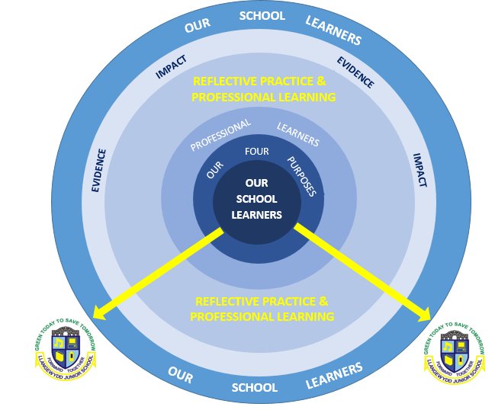

Our reflective practice and professional learning subscribes to these four elements:
- Collaboration - working in triads and groups within, across and beyond our school as a key feature of our reflective practice. We welcome opportunities to work productively with all partners in learning in a climate of mutual support in order to extend our professional effectiveness.

- Year group triads discuss teaching and learning in order to share good practice and to reflect upon the impact of different aspects of teaching upon standards of learning e.g. through planning/book scrutiny exercises, analysis of data. Teachers also undertake peer-to-peer lesson observations with a specific teaching and learning focus.
- AoLE team meetings focus on updating subject knowledge and pedagogy in line with current developments and initiatives in order to secure high standards of teaching and learning.
- Staff meetings/INSET – aspects of teaching and learning are regularly discussed and evaluated. They are a focus for INSET with a view to securing improved standards of teaching and learning.
- SLT meetings - aspects of teaching and learning are regularly discussed and evaluated with a view to securing improved standards.
- Cluster meetings and school-to-school partnerships with a focus on sharing good practice in teaching and learning.
- Pupil Voice Teaching and Learning Committee – Pupil Voice meetings are a forum for reflecting on and contributing to decisions made about aspects of teaching and learning.

- Reflective Practice – we pursue opportunities to reflect critically and candidly on our current practice. We are open to others’ reflections on how our practice can be improved or developed.

- Our teachers and AoLE team members continuously update their subject knowledge and teaching practice in line with current developments and initiatives.
- Our teachers evaluate and reflect upon their teaching and its impact upon learning outcomes. They use their evaluations to refine teaching and learning and to inform future planning:

PLAN
EVALUATE
IMPLEMENT

- Our teachers are familiar with the Professional Standards for Teaching, use these to reflect upon their own practice and engage in identifying priorities for their own professional learning.
- Our teachers use professional development courses and input offered by external providers and other schools, as an opportunity to reflect upon their own/the school’s current practice and ways in which this can be improved.

- Use of data and research evidence – our teachers, as reflective practitioners, are encouraged to build their skills in making use of research and data.

- Our teachers and AoLE team members continuously update their subject knowledge and teaching practice in line with current research, developments and initiatives.
- Our teachers use data analysis as a means of informing self-evaluation. The outcomes of termly teacher summative assessments and summative tests e.g. National Reading, Numeracy and Reasoning tests (Personalised Assessments) are analysed in order to identify what learners can do, as well as next steps in their learning. Such analysis focuses our teachers’ attention on refining aspects of teaching and learning in order to address areas for improvement.

- Coaching and mentoring – interaction takes place with coaches and mentors on programmes and in reflective practice in school.

- Year group triads discuss teaching and learning in order to share good practice and to reflect upon the impact of different aspects of teaching upon standards of learning e.g. through planning/book scrutiny exercises, analysis of data. They also undertake peer-to-peer lesson observations with a specific teaching and learning focus.
- Teachers plan their own Professional Learning programme in conjunction with the Headteacher and their SLT Team Leader as a result of the Performance Management process.
- Our teachers receive day-to day support from their SLT Team Leader.
- NQTs receive day-to day support from our Induction Mentor and periodic support from an external verifier. Effective induction is achieved within our school through a partnership between the NQT, Induction Mentor and other key members of staff including the SLT and other teachers who can share good practice.
- AoLE team members provide support to others by updating their subject knowledge and pedagogy in line with current developments and initiatives in order to secure high standards of teaching and learning.
- Any coaching and mentoring that takes place within the context of any accredited programme e.g. NPQH

Homework / Blended Learning
We ‘blend’ face to face teaching and learning that takes place at our school with tasks and activities that the children are asked to complete at home – online, offline or a combination of both. Homework tasks and activities are designed to pre-teach, consolidate, reinforce or extend skills and understanding in Language, Literacy and Communication as well as in numeracy and the topic being studied in class. The children are set three pieces of homework every half term (one per fortnight). One of these homework tasks will be ICT-based using the Google Classroom or Seesaw platform where online assignments and any accompanying digital resources are uploaded by teachers. At times, online tasks may be started in school and completed at home or vice versa. Homework consists of:
- one homework task every fortnight. All homework tasks are relevant to and meaningful in the context of the current topic. The nature of these tasks will vary e.g. inquiry-based research, problem-solving, applying literacy, numeracy or other skills taught, investigations, practical tasks such as model-making. We aim to achieve a balance of different types of tasks across the AoLEs throughout the year.
- a minimum of six assigned ‘Bug Club’ books to be read at home (this is in addition to reading books given in school).
- completion at home of activities within the Reading Eggs/Express literacy interventions and Maths Seeds/Mathletics numeracy intervention .
- practising of specific multiplication tables.
Homework/Blended learning is similar in our CARE base / LRC, however, it is given on an individual basis according to the needs and anxieties of each child.

Equal Opportunities
All learners regardless of ability, gender, religion, social background, disability and race will have access to our curriculum provision. All activities are planned in such a way as to encourage full and active participation by all learners so that they can develop their skills, knowledge, confidence and enjoyment of learning. Every child is valued and perceived as unique. We aim to ensure that our teaching responds to the learning needs of the individual pupil, challenging them to the full extent of their capabilities and providing them with opportunities to demonstrate fully what they know, understand and can do. Our children’s well-being is always central to everything we do.
Differentiation
All learners have equal access to our curriculum. Our teaching and learning is differentiated appropriately (from the top down) so that all learners are challenged and supported in their learning in order to achieve maximum educational and personal benefit. Our methods of differentiation include differentiation:
- by task.
- by grouping.
- by resource.
- by support.
- by questioning.
- by assessment and feedback.
- by teaching style.
Disability
In accordance with the statutory requirements, our school aims to make the curriculum accessible to all pupils as far as is reasonably practicable. The school has an Accessibility Plan that is available to parents on request.
Additional Learning Needs
If a child is identified as having a concern in one of the areas of need then our school does all it can to meet these individual needs. We are committed to implementing the requirements set out in the ALN Act (Wales) in providing for pupils’ needs. A range of assessment strategies are utilised to help identify particular difficulties and various strategies and resources are used to support pupils. External agencies can be involved in order to provide more specialist assessments and advice.
All children have a One Page Profile (OPP) which details what is important to the child and how they want to be supported. We follow a graduated response to ensure the pupils’ needs are being monitored and met. A Learning Plan can be set up when it is felt a child’s needs require closer monitoring. The school provides an Individual Development Plan (IDP) for each pupil on the Additional Learning Needs register. This document is compiled from contributions made by those involved with the child, including the pupil themselves, following a Person Centred Planning (PCP) meeting. It sets out the nature of any needs and outlines the additional learning provision that the pupil will receive. This document is reviewed annually with parents and outside agencies. It is a working document and targets can change and be revisited when deemed appropriate.
Our CARE base and LRC children will often have more reviews with parents and outside agencies due to the nature of their needs. As well as parents having access to teachers’ emails, we have an outside line directly to the bases and parents can contact staff whenever they need to.
This policy should be read in conjunction with the following policies:
- Curriculum Policy
- Blended Learning Policy
- Assessment Policy
- Assessment and Feedback Policy
- ALN Policy
- AoLE policies
- Literacy across the Curriculum Policy
- Numeracy across the Curriculum Policy
- ICT, DCF &e-safety policies
- MAT Policy
- Behaviour Policy

Monitoring and Review

Monitoring
Monitoring of the curriculum – planning, coverage and standards of teaching and learning, is conducted by the Headteacher, Deputy Headteacher, Assistant Headteacher, Senior Leadership Team and AoLE teams. This is done in several ways including:
- Pupil Progress meetings and subsequent action plans
- book scrutinies
- monitoring planning
- analysing assessment data
- monitoring targets
- lesson observations
- learning walks
- Listening to Learners
- looking at displays
- informal discussions with staff
- monitoring and review of curriculum-related SIP targets
Review
As we implement Curriculum for Wales, we are aware of the need to monitor our Teaching and Learning Policy, and to review it regularly so that we can take account of new initiatives and research, Curriculum for Wales guidance, developments in technology and changes to the physical environment of the school. Our Teaching and Learning Policy will be reviewed bi-annually (or sooner as necessary) by the Assistant Headteacher, the Headteacher and the nominated governor. The necessary recommendations for improvement will be made to the Governors.
Signed by the Chair of Governors on behalf of the Governing Body: M. Dixon
Date approved: 27.01.2027 (by full Governing Body)
Signed by Headteacher: K. Green Date of next review: January 2027

Appendices

Appendix 1 – Our Pedagogical Principles

Appendix 2 – Q Matrix

Appendix 3 – Questioning – A Placemat to support the planning of questions

Appendix 4 – Our Teaching and Learning Lesson Map

Appendix 5 – A sample from our weekly Lesson Planning Template

Appendix 6 – Our Weekly Lesson Planning Prompt Sheet

Appendix 7 – Pupil Entitlement – Teaching and Learning

Appendix 7a – Pupil Entitlement – Learner Targets

Appendix 7b - Pupil Entitlement – Assessment for Learning

Appendix 7c - Pupil Entitlement – Learning Environment (Areas/Zones)

Appendix 7d - Pupil Entitlement – Learning Environment (Display)

Appendix 1 – Our Pedagogical Principles

Appendix 2 – Q Matrix
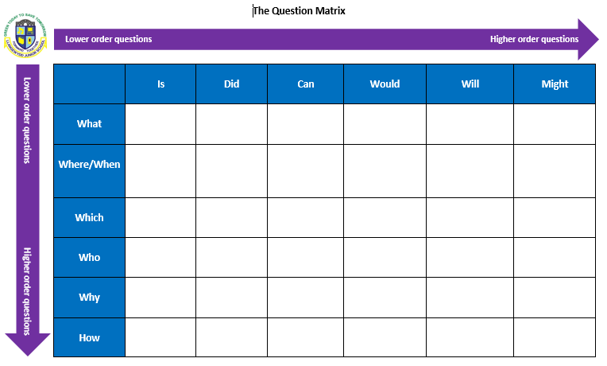

Appendix 3 – Questioning – A Placemat to support the planning of questions
Appendix 3 – Questioning – A Placemat to support the planning of questions

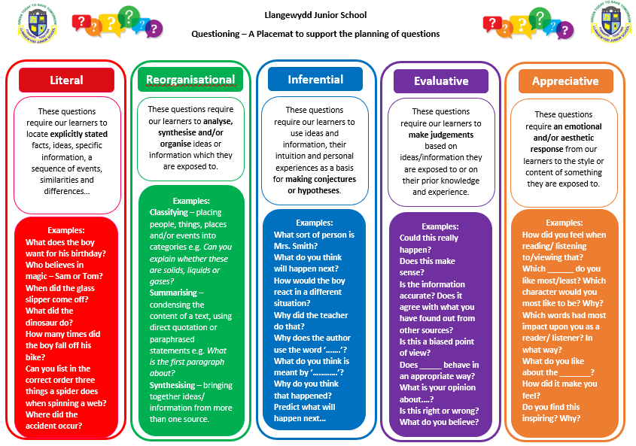
Appendix 4 – Our Teaching and Learning Lesson Map
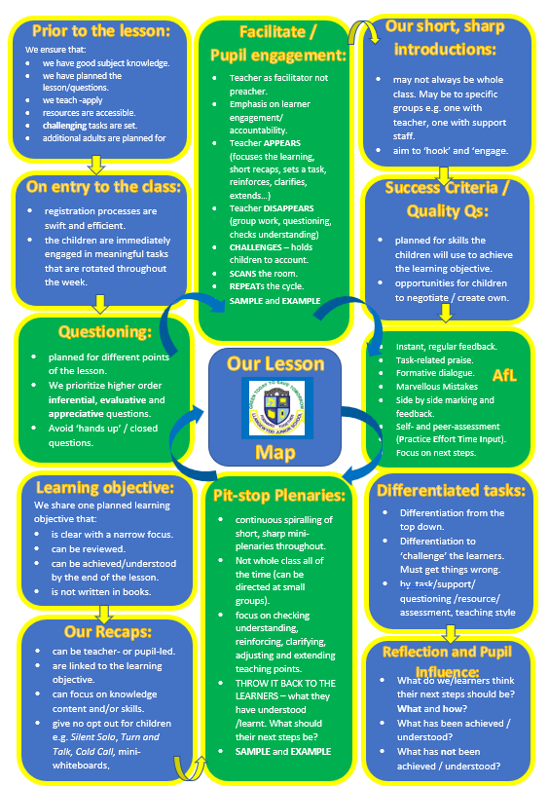
Appendix 5 – A sample from a Weekly Lesson Planning Template
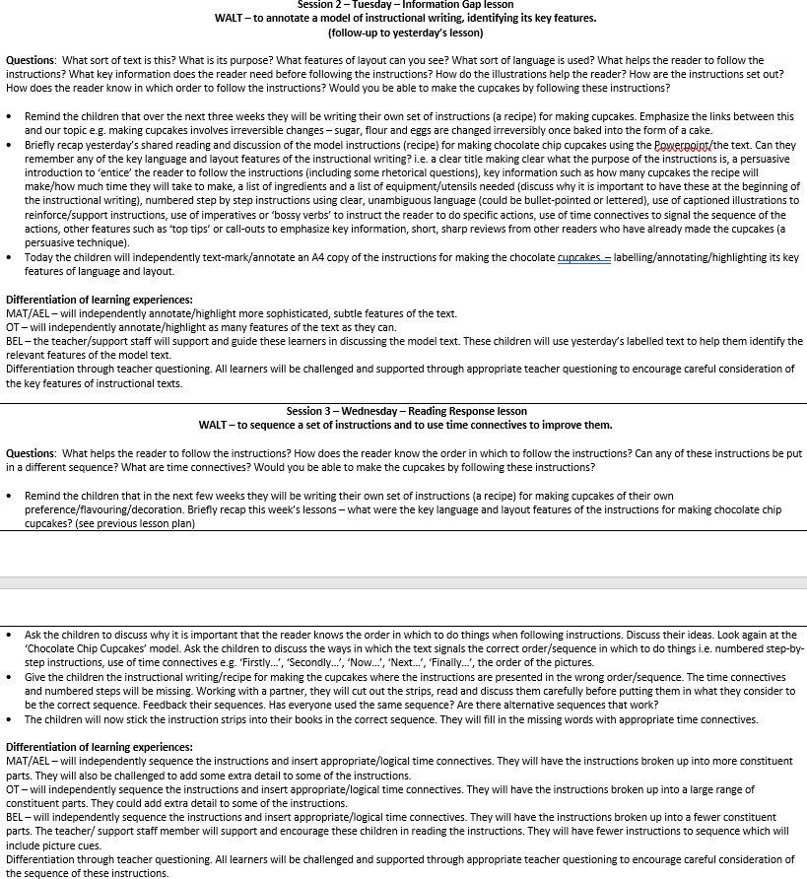

Appendix 6 – Our Weekly Lesson Planning Prompt Sheet
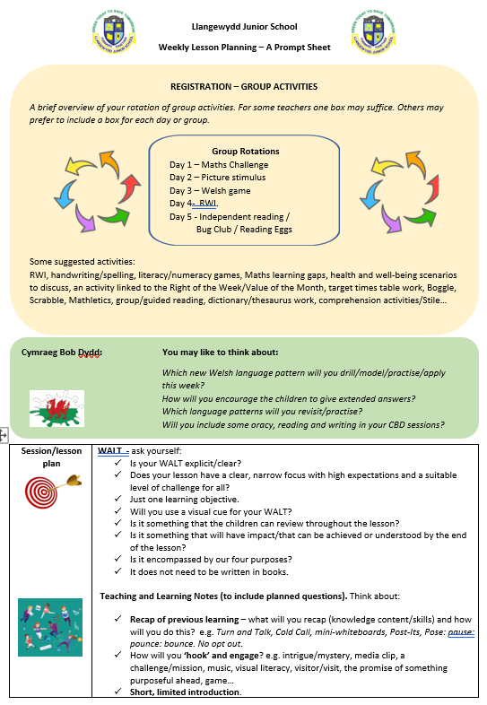
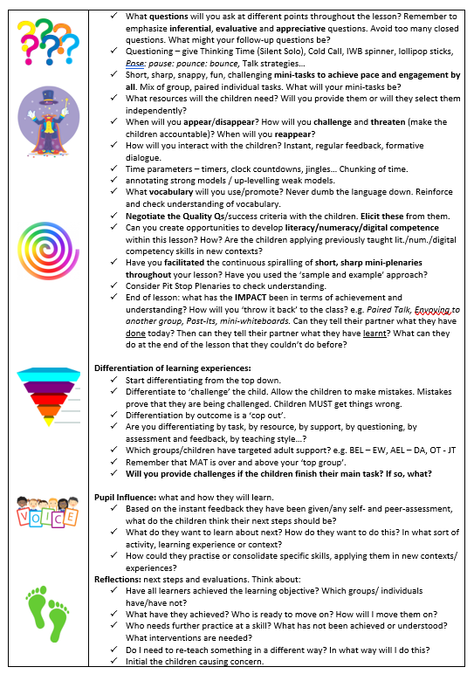
Appendix 7 – Pupil Entitlement – Teaching and Learning
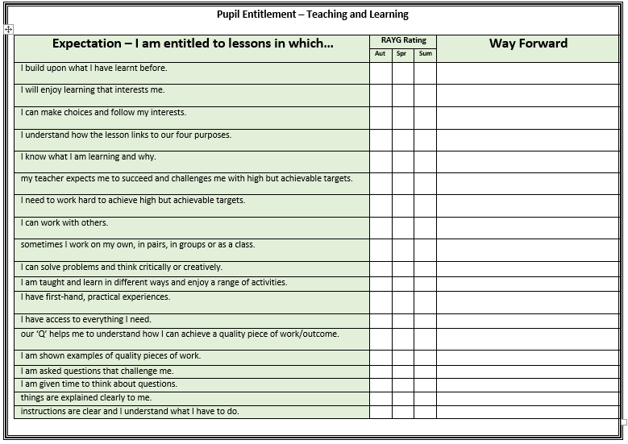

Appendix 7 – Pupil Entitlement – Teaching and Learning (cont’d)
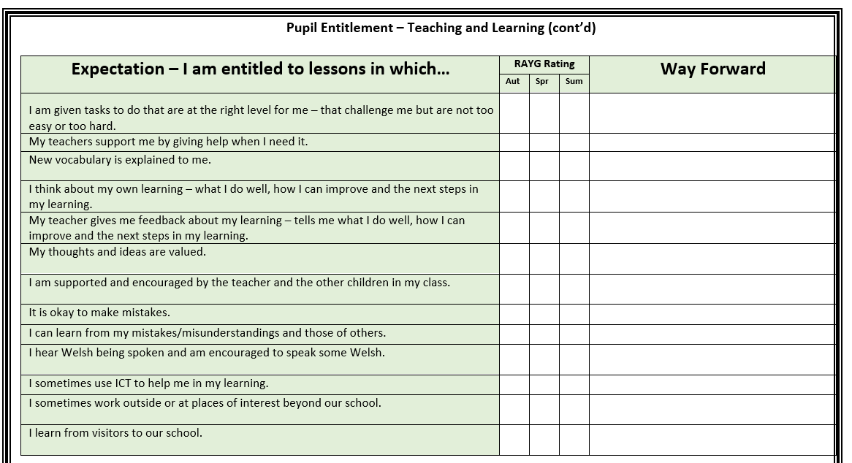

Appendix 7a – Pupil Entitlement – Learner Targets
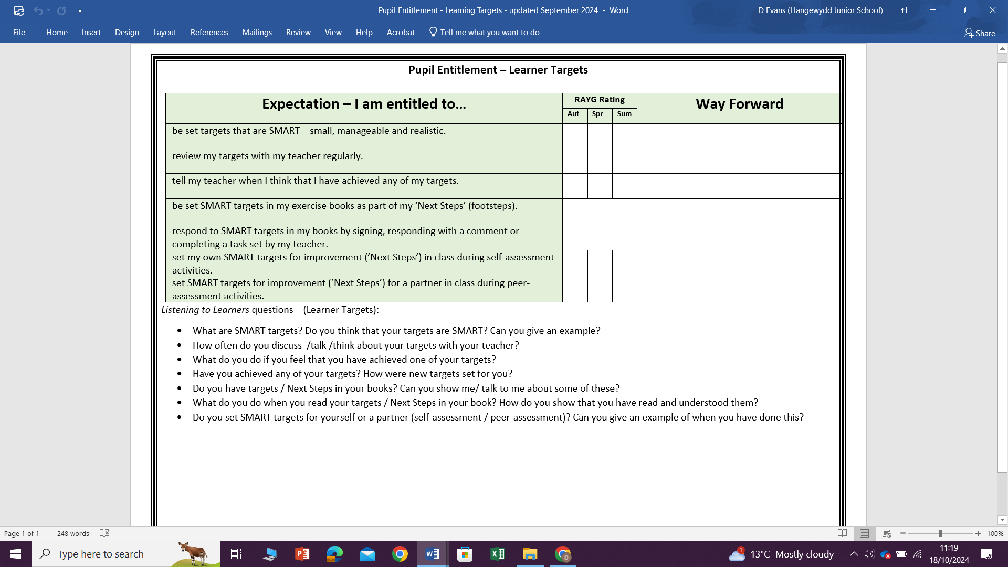

Appendix 7b – Pupil Entitlement – Assessment for Learning
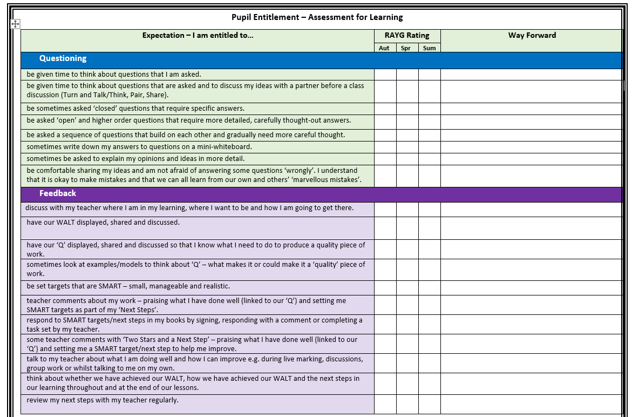

Appendix 7c – Pupil Entitlement – Assessment for Learning
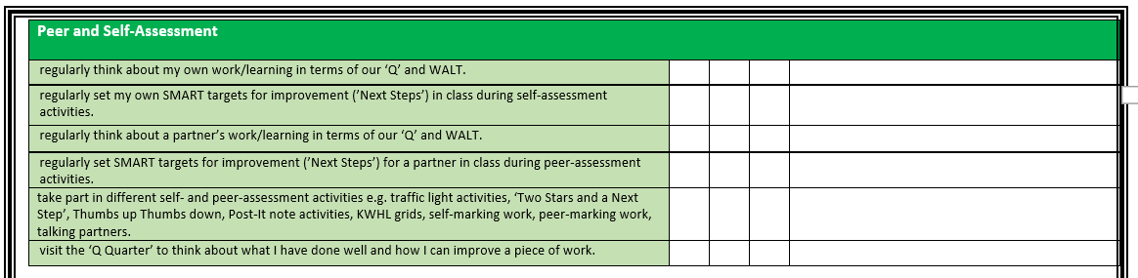

Appendix 7d – Pupil Entitlement – Learning Environment (Areas/Zones)
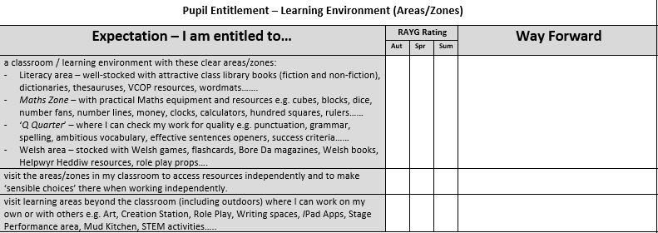

Appendix 7e – Pupil Entitlement – Learning Environment (Display)
