Curriculum Policy

Date | Review Date | Co-ordinator | Nominated Governor
January 2026 | January 2027 | Mr. Darryl Evans | AoLE Leads

United Nations Convention on the Rights of the Child
At Llangewydd Junior School, we put the United Nations Convention on the Rights of the Child (UNCRC) at the heart of our school’s planning, policies, practice and ethos. We are a Rights-Respecting School and teach about children’s rights - modelling rights and respect in all our relationships: between teachers/adults and our learners.
The UNCRC underpins our school vision and aims. We encourage our children to:
- listen to others and respect their ideas.
- learn about their rights, respect the rights of others and to inform others of children’s rights.
Introduction
This Curriculum policy outlines the purpose and design of the curriculum at Llangewydd Junior School. It is shaped by our commitment to enabling all our learners to achieve the highest academic and personal standards of which they are capable. In designing and continuously refining our curriculum, we aim to provide our learners with a broad and balanced curriculum that enables them to realise the four purposes and equips them for ongoing learning, work and life. Whilst implementing our curriculum, we are continually using our own learning to evaluate and refine our approach.
At Llangewydd Junior School, as lifelong learners, we believe that learning should be a positive and inspiring experience for us all with well-being and enjoyment at its core. Through our curriculum provision, we equip our learners with the skills, knowledge and understanding necessary to be able to make informed choices about the important things in their lives. Through placing an emphasis on Pupil Voice, we empower our children to make decisions about their own learning pathways and enable them to drive their own tailor-made curriculum.
We work hard to ensure that all learners experience the highest quality teaching and learning during their time at Llangewydd Junior School, offering a broad and balanced curriculum that promotes learners’ spiritual, moral, social, cultural, mental and physical development and relates to local, national and global contexts. Using the experience, enthusiasm and expertise of staff, we provide engaging and inspiring teaching and learning experiences that are differentiated appropriately to meet children’s individual needs and abilities in inclusive classroom and outdoor environments. Our curriculum is driven by Pupil Voice, our Teaching and Learning Policy, our evolving theme maps (See Appendix 1) and the Curriculum for Wales agenda.

Aims
In undertaking our process of designing, planning, implementing and evaluating our curriculum, we aspire to develop a curriculum that will:
- enable our learners to realise the four purposes and equip them for ongoing learning, work and life.
- engage our learners in holistic, cross-curricular, topic-based learning informed by salient pedagogical principles.
- build high expectations and enable all learners to achieve their full potential.
- offer a broad and balanced education that enables our learners to make links between the different areas of learning and experience and to apply their learning to new situations and contexts.
- support progression along a continuum of learning, working with our cluster feeder schools and comprehensive school to ensure that there is alignment in the transitions across a 3 to 16 continuum.
- support learners’ health and wellbeing.
- support learners’ development of the knowledge, skills and experiences that are the foundation of being an informed citizen.
- recognise our learners’ identity, language(s), ability and background and the different support they may need given their particular circumstances.
- reflect the diversity of perspectives, values and identities that shape our learners’ locality and Wales, as well as develop an understanding of the wider world.
- be shaped by Pupil Voice, co-constructed and responsive to learners, their families and the wider community.
- enable our learners to make sense of growing up in contemporary Wales and of issues that will be important into the future, including well-being, sustainable development and citizenship.
- enable our learners to develop an understanding of their rights and the rights of others.
The Curriculum
The school’s curriculum follows statutory requirements and the requirements of:
- Curriculum for Wales.
- the mandatory curriculum elements (Religion, Values and Ethics framework, Relationships and Sexuality Education (RSE), Welsh and English)
- Agreed Syllabus for RVE.
- Literacy and Numeracy Framework.
- Digital Competence Framework (DCF).
In implementing Curriculum for Wales, we are designing, implementing, evaluating and refining a curriculum that:
- contains the six areas of learning and experience.
- encompasses the statements of ‘What Matters’.
- reflects the principles of progression set out in the progression code.
- includes the mandatory curriculum elements (Religion, Values and Ethics framework, Relationships and Sexuality Education (RSE), Welsh and English)
- encompasses the mandatory cross-curricular skills (Literacy, Numeracy and Digital Competency)
- develops integral skills within a wide range of teaching and learning – creativity and innovation, critical thinking and problem-solving, personal effectiveness, planning and organising.
- incorporates opportunities for learning and consideration of cross-cutting themes – Local, national and international contexts, Careers and work-related experiences, Human Rights Education and Diversity.
(See Appendix 2)
Principles of our Curriculum Design Process
In designing, implementing, evaluating and refining our curriculum, we are developing high-level curriculum and assessment design, informed by the Curriculum for Wales Guidance, and progress priorities to support curriculum realisation set out in our School Improvement Plan. We use our own learning throughout our curriculum design process to perpetually evaluate and refine our approach. The principles that inform this approach include the following:
- Development through co-construction – Within our school, we co-construct our curriculum through adopting a collaborative approach to curriculum design, sharing ideas and expertise, as well as problems and jointly developing solutions. Every half term, year group teams meet to review curriculum planning with reference to the Curriculum for Wales and to plan new cross-curricular topics informed by Pupil Voice input. Draft curriculum plans may then be subsequently shared with AoLE teams who consider whether aspects of the planning can be refined as well as evaluating curriculum coverage and skills progression for their AoLE throughout the school. These plans are then refined by year groups in response to feedback from the AoLE teams before being implemented the following half term. Co-construction also takes place between schools in the context of our cluster curriculum groups, between phases and with stakeholders beyond the education system such as local businesses, professionals, artists, theatre companies.
- Equity in co-construction – In co-constructing our curriculum, we value the contributions made by every voice within the process.
- Space and time to think and engage – Our school acknowledges that co-constructing solutions takes longer. High-quality thinking, solutions and relationships are developed over a prolonged period of engagement. We also recognise that curriculum design is a continuous process of refinement, rather than a project with a final outcome. Non-contact time where teachers can genuinely collaborate on curriculum design in year group teams is planned for. Similarly, directed time regularly provides AoLE teams with opportunities to focus on aspects of curriculum design including contributing to planning, considering curriculum coverage and evaluating skills progression.
- Clear understanding of ‘why’ things are learned and done – Epistemic knowledge supports our systems to help us make better decisions about what should be learned. In designing our curriculum, we self-challenge our provision, reasoning why specific learning matters and what the essence of that learning is.
- Critical engagement with expertise – In designing our curriculum, we engage intellectually with quality research, expert input and international expertise.
- Leadership at all levels - A system of distributed leadership at our school enables all teaching and classroom support staff to meet our curriculum vision and aspirations. It provides clear direction, challenge and high expectations whilst also allowing ownership by individual teachers and support staff, year group teams and AoLE teams. Such distributed leadership creates a culture of trust and empowerment.
Our Pathway to Curriculum for Wales 2022
Completed Phase | Engagement | Our school has developed an understanding of the conceptual model of the curriculum. This involved engaging and sense-making with materials and literature, and updating our vision with stakeholders.
Completed Phase | Design, planning and trialling  3 terms 2020-2021 | We started to develop high-level curriculum and assessment design, informed by the guidance and progress priorities to support curriculum realisation set out in our School Improvement Plan. We are always trialling aspects of design, new approaches and pedagogy, using our own learning to evaluate and refine our approach.
Completed Phase | Evaluating and preparing for first teaching  2-3 terms 2021-2022 | We evaluated initial designs and trialled further approaches. We began to finalise medium-term planning.
Completed Phase | First teaching and ongoing refinement  September 2022 onwards | We implemented our Curriculum for Wales approach, perpetually evaluating and refining our approach.
Current Phase | Ongoing refinement | Continuous improvement

Curriculum Organisation and Implementation
The school’s curriculum follows the statutory requirements of Curriculum for Wales. It:
- enables our learners to develop in the ways described in the four purposes.
- is suitable for learners of different ages, abilities and aptitudes.
- is broad and balanced.
- makes provision for learning and teaching that encompasses each of the six Areas, including the mandatory elements. Our curriculum only does this if it incorporates all the statements of what matters.
- makes provision to develop the mandatory cross-curricular skills (literacy, numeracy and digital competence).
- provides for learning that accords with the RSE Code and is developmentally appropriate for our learners.
- provides our learners with the learning and teaching of RVE.
- provides for appropriate progression which is set out in accordance with the principles of progression set out in the Progression Code. Our assessment arrangements are informed by those principles of progression.
- makes ongoing assessment arrangements to support learner progression throughout the school year.
- makes arrangements for assessing the ability and aptitude of learners in respect of the curriculum, on entry to our school, to identify the next steps in their progression and the learning and teaching needed to support that progress.
- takes account of each learner’s additional learning needs (ALN).

At Llangewydd Junior School, we implement cross-curricular, thematic or topic-based learning that blends the six Areas of Learning and Experiences. Our thematic approach is shaped by the four purposes, responsive to Pupil Voice and informed by pedagogical principles. Before every topic, through designated ‘Pupil Voice/Influence’ time, the Year 6 Pupil SLT visit each class and discuss with the children aspects of a topic that they would like to explore. The outcomes of this ‘Pupil Voice/Influence’ exercise are shared with all class teachers and this informs their topic planning. Pupil Voice/Influence ideas will naturally evolve during the course of a topic and so teachers’planning is adjusted accordingly. This approach invests the children with ownership of their learning, making it more engaging and purposeful for them. Each half term, topics with a specific AoLE bias are chosen and a balance between the AoLEs is achieved throughout the academic year (See Appendix 3). An example of an academic year’s curriculum structure is:

Autumn Term | Humanities Topic (History bias)
Spring Term 1 | Science and Technology driven topic
Spring Term 2 | Health and Well-being driven topic
Summer Term 1 | Expressive Arts driven topic
Summer Term 2 | Humanities Topic (Geography bias)

Each topic is launched with a ‘Super Start’ - immersion activities or experiences to engage the children’s interest and enthusiasm for their anticipated learning. Similarly, each topic culminates with a ‘Fabulous Finish’ event to celebrate or showcase the learning that has taken place with parents, governors and other stakeholders.
- Literacy, numeracy and digital competency skills are taught throughout all our topics.
- Our ‘Writing Journey’ literacy lessons have a sequence of lessons that progress over a three week period and culminate with a ‘big write’.
- Read, Write Inc. lessons to address phonics gaps.
- Guided Reading sessions (with each group reading once per fortnight) aims to achieve a balance between fiction, non-fiction, poetry and digital literacy throughout each term.
- Listening to individual readers. Each learner is listened to reading by an adult once a fortnight.
- Welsh as a Second Language is linked to thematic, cross-curricular topics as much as possible but discrete lessons may be taught where more appropriate.
- Cymraeg Bob Dydd: a daily 15 -20 minute focus on Welsh oracy which may incorporate elements of reading and writing.
- British Sign Language is taught incidentally and across different contexts e.g. signs linked to greetings, school day routines and topics.
- Reading Eggs and Reading Express are literacy interventions accessed by specific learners independently throughout the school day.
- Mathletics and Maths Seeds are maths programs accessed by learners independently throughout the school day to reinforce and consolidate maths concepts and skills.
We implement a fluid, flexible timetable structure where sequential lessons build cumulatively and activities may be sustained over a series of lessons in order to secure quality outcomes (See Appendix 4).

Pupil Voice and how it co-constructs our curriculum
Our curriculum is co-constructed and shaped by Pupil Voice processes. Our Pupil Voice Committees have been created to allow all our learners to have a voice that is heard and acted upon. Children from all our classes are represented in our Pupil Voice Committees and have responsibility for discussing and making decisions about different aspects of school life including our curriculum. Our seven Pupil Voice Committees are:
Pupil Voice Committee
(consisting of the Head/Deputy Head Boy and Girl and a representative from each of the Pupil Voice committees below. These give feedback about the outcomes of the other committees. This committee has overarching responsibilities.)

Teaching and Learning Committee Criw Cymraeg Digital Leaders
Playground Leaders Committee
Eco Committee Rights Ambassadors

Before every topic, through designated ‘Pupil Voice/Influence’ time, the Year 6 Pupil SLT visit each class and discuss with the children aspects of a topic that they would like to explore. The outcomes of this ‘Pupil Voice/Influence’ exercise are shared with all class teachers. Pupil Voice/Influence ideas will naturally evolve during the course of a topic and teachers will adapt their planning accordingly. This approach invests the children with ownership of their learning, making it more engaging and purposeful for them.
We encourage our children to take responsibility for their own learning and to assume ownership of the learning process as much as possible through:
- creating opportunities for them to initiate and influence teaching and learning e.g. through pre-planning ‘Pupil Voice’ sessions led by the Year 6 SLT, creating ‘reflection and pupil influence’ time in lessons where learners can think about what they want to learn next/their next steps in learning.
- creating opportunities for learners to make personal choices and to follow their interests in curriculum activities.
- our Assessment for Learning (AfL) processes.
- ensuring that status is given to Silent Solo ‘thinking time’.
- sharing and negotiating learning objectives (our WALTs) and our ‘Q’ – what is needed for quality outcomes.
- placing an emphasis on modelling.
- involving our learners in setting their own next steps.
- celebrating children’s positive attitudes and efforts.
- providing high quality feedback to children regarding their learning.
- encouraging and facilitating self- and peer-support and assessment.
- recognising and celebrating children’s achievements in all areas of life.

Welsh / BSL / Multilingualism
Llangewydd Junior School is an English medium school and no learners come from Welsh speaking homes. We take pride in our role as Welsh and BSL educators and actively promote and develop the use of Welsh and BSL as living languages. We aim to make our children’s learning across the curriculum as multilingual as possible.
In addition to Welsh lessons and BSL taught within the context of our cross-curricular topics where we teach Welsh and BSL as additional languages, we use a variety of strategies to promote their use:
- Our 'Cymraeg Bob Dydd' initiative aims to promote the children's confidence in, enjoyment of and enthusiasm for speaking everyday Welsh. During these daily 15-20 minute sessions, emphasis is placed on drilling, modelling, practising and applying specific Welsh language patterns. The Cymraeg Bob Dydd sessions place an emphasis on the use of sentence builders, the playing of Welsh language games, chanting rhythmic language patterns etc. Each classroom has a Wal Cymraeg which is used as the focal point for Cymraeg Bob Dydd sessions and Welsh resources. Each year group uses the progressive language patterns in the CBD Continuum as their starting point for CBD activities.
- A ‘Siaradwr yr Wythnos’ is awarded in each class every week to a learner who has made efforts to speak Welsh with fluency, accuracy or enthusiasm.
- Almost all instructions are given in Welsh or bilingually so that the children regularly listen and respond to the Welsh language e.g. during registration, when lining up, tidying up, asking to go to the toilet, in transitions between lessons.
- School staff and learners greet each other throughout the school day in Welsh. Learners are encouraged to use the language patterns they know beyond the classroom e.g. in corridors, in the playground, in the canteen.
- Our ‘Criw Cymraeg’, consisting of a representative from each class, promotes the use of Welsh throughout the school. They are currently working on actions working towards achieving the Gold Award of the Siarter Iaith.
- Some subject-specific Welsh appropriate to learners’ age and ability is used within topic-based teaching.
- The use of Welsh is promoted through collective worship.
- Our learners are encouraged to speak Welsh at our ‘Siop Tuc’, in our canteen and in the playground.
- BSL. We are beginning to introduce BSL alongside English, Welsh and other languages in the curriculum. We have adopted an approach whereby BSL will be taught/used as an incidental part of everday school life. We will aspire to use and respond to BSL signing in:
- greeting people
- in the classroom – interactions between teachers and learners, learners and learners…, BSL signs linked to topic work.
- at key times of the school day e.g. at breaktimes, at lunchtimes, at the healthy tuck shop, in the school canteen
- in assemblies e.g. greetings, songs
- in special events such as concerts, Fabulous Finishes
- beyond the school e.g when on educational visits, when in the local community
- using and responding to BSL visuals
We use the following resources to support us in introducing BSL to our school:
- CSCJES BSL continuum – we have a half-termly focus on the signing of specific word and phrases.
- BSL App.
- BSL website.
- BSL resources on Hwb including BSL Awareness, BSL Progression Step 1 resources, Storytime in BSL.
- In-house videos to support staff.
At present, this aspect of our curriculum is being developed and a policy regarding its implementation is being shaped.

Teaching Approaches
In shaping our curriculum, we do not place an emphasis on any particular teaching approach, understanding that decisions about teaching and learning are very context and purpose specific, and are best taken by our teachers themselves. Teaching and classroom support staff use different teaching styles such as direct instruction, inquiry-based learning and collaborative learning to suit the ability and learning styles of our learners in a wide variety of teaching and learning contexts. We:
assess the impact of the teaching approach through pupil progress.
match their needs to the most appropriate pedagogical approach.
identify our learners’ greatest needs

repeat

Within our curriculum, our teaching approaches are informed by pedagogical principles that we view as having integrity depending on the learners and their specific contexts. These may include:
- creating authentic contexts for learning.
- encouraging learners to take responsibility for their own learning.
- supporting social and emotional development and positive relationships.
- encouraging collaboration.
- promoting sustained pupil effort to reach high but achievable targets.
- employing a broad repertoire of teaching approaches.
- promoting problem solving, creative and critical thinking.
- building on previous knowledge and experience to engage interest.
- focusing on the four purposes.
- using Assessment for Learning to accelerate progress.
- making connections within and across Areas of Learning and Experience.
- reinforcing cross-curricular responsibilities in literacy, numeracy and digital competence.
It may be appropriate to teach the whole class or to work with small groups and occasionally with individual learners. Classroom support staff are used effectively throughout the school to provide additional support for groups and individuals, helping to support specific learning difficulties, weaknesses or barriers to learning as well as challenging and extending more able learners.

Planning
Planning is carried out in three phases (long-term, medium-term and short-term). Our current planning processes are as follows:
- Medium-Term Planning.
Prior to each half term, year group teams meet to collaborate on medium term topic plans that are driven by Pupil Voice. Each half term, medium term planning with a specific AoLE bias is undertaken although an emphasis is placed on blending AoLEs (only when links have integrity) within the context of topics. Our medium-term planning ensures an appropriate balance of learning across the AoLEs is achieved throughout the academic year.

- Long-Term Planning.
As a whole school, teachers have developed a long-term plan that maps out opportunities for developing learners’ skills/covering curriculum content across the AoLEs in each year group throughout the school. This long term plan/whole school curriculum map provides an overview of coverage and progression in learning as opposed to being detailed Schemes of Work. It will be adapted regularly to acknowledge a fluidity in medium term topic plans resulting from a responsiveness to Pupil Voice and real life local, national and global events.

- Short-Term Planning.
Teachers plan and organise their teaching within the agreed medium- term topic plans on a weekly basis. Weekly, short term plans are completed by individual teachers (or collaboratively in year group teams). These plans are specific to individual classes and are always informed by an evaluation of pupil progress in learning. Teachers determine particular activities and the nature of those activities to support and challenge the specific needs of the pupils in their classes within the context of themes jointly shared by classes. Teaching plans are refined and adapted on a day-to-day basis according to teachers’ evaluations of pupils’ learning within their classes:

PLAN

EVALUATE
IMPLEMENT

The level of detail in teachers’ short term planning varies according to the preferences of individual teachers although all lesson plans include (Appendix 4):
- The learning objective or WALT (We are learning to…)
- Teaching and learning notes to include planned questions.
- Notes about Differentiation for different groups of learners and/or individual learners.

Our Teaching and Learning Environment
At Llangewydd, we perpetually strive to improve our teaching and learning environments, believing that a carefully planned environment sets the climate for effective teaching and learning. In order to fully engage with learning, our children require rich, stimulating environments where they can explore and experiment with ideas, collaborate actively with their peers and make dynamic connections with a clear sense of purpose to construct meaning. In recent years, we have created zones both within and adjoining our classrooms to promote independent use of resources and high-quality work by the children. These include:
- a Literacy area – well-stocked with attractive class library books (fiction and non-fiction), dictionaries, thesauruses, literacy resources, word mats, and a range of literacy scaffolds.
- a Maths Zone – with practical Maths equipment and resources e.g. blocks, number fans, number lines, hundred squares, clocks, calculators, money.
- a ‘Q Quarter’ – where the children are encouraged to check their work for quality e.g. punctuation, grammar, spelling, ambitious vocabulary, effective sentence openers, ‘Q’ criteria.
- a Wal Cymraeg – a Welsh area stocked with Welsh games, flashcards, Bore Da magazines, Welsh books, Cymraeg Bob Dydd resources, role play props.
- other areas where learners can complete independent work e.g. a creative area, a Digi-Den…
Our classroom displays reflect the topics being studied by the children. We believe that our learners are entitled to learn in an inclusive classroom/learning environment where everyone’s quality work is celebrated in attractive displays. Our classroom displays:
- support and challenge the children in their learning e.g. through use of questions and prompts that encourage them to interact with display content.
- place an emphasis on multilingualism.
- include a ‘Pupil Voice’ display to show how the children are making decisions that shape our teaching and learning.
- include literacy, numeracy and topic working walls with prompts, vocabulary, models and strategies that the children can use in their current learning.
- include a Wal Cymraeg display that focuses on current Welsh language patterns being practised.
- may include learners’ ‘own board’.
We have also developed teaching and learning areas beyond the classroom including our ‘Reading Rainforest’ school library, a kitchen, two computer suites, a sensory room, a sensory circuit, a radio station, pop-up green screen studios, an outdoor classroom and a variety of outdoor learning areas. These are used effectively to promote independent learning.
Outdoor Learning
Outdoor learning takes place in our outdoor classroom or ‘Eco House’, in our woodland areas, on our school playgrounds and elsewhere in our extensive school grounds. Opportunities are planned throughout our curriculum to use outdoor settings to develop the children’s knowledge, skills, attitudes and behaviour and to promote the personal, social and academic benefits of engaging with the outdoor environment. Each class has a weekly outdoor learning lesson led by our Outdoor Learning lead teacher and supported by the class teacher.

Equal Opportunities
All learners regardless of ability, gender, religion, social background, disability and race will have access to our curriculum provision. All activities are planned in such a way as to encourage full and active participation by all learners so that they can develop their skills, knowledge, confidence and enjoyment of learning. Every child is valued and perceived as unique. We aim to ensure that our curriculum responds to the learning needs of the individual pupil, challenging them to the full extent of their capabilities and providing them with opportunities to demonstrate fully what they know, understand and can do. Our children’s well-being is always central to everything we do.
Differentiation
All learners have equal access to our curriculum. Our curriculum provision is differentiated appropriately so that all learners are challenged and supported in their learning in order to achieve maximum educational and personal benefit. Our methods of differentiation include differentiation:
- by task.
- by grouping.
- by resource.
- by support.
- by questioning.
- by assessment and feedback.
- by teaching style.
Disability
In accordance with the statutory requirements, our school aims to make the curriculum accessible to all pupils as far as is reasonably practicable. The school has an Accessibility Plan that is available to parents on request.

Religion, Values and Ethics
Religion, Values and Ethics is accessed by all pupils. Parents and carers do not have the right to withdraw their children from RVE.
Collective Worship
All pupils are expected to take part in daily collective worship. Pupils in the Sunshine and Rainbow classes will take part, dependent upon the nature of the provision and their specific needs/anxieties. The worship is mainly of a broadly Christian character but it is not distinctive of a particular Christian denomination.
The school has a programme of collective worship involving some whole-school assemblies, class assemblies and celebration assemblies.
Parents have a right to withdraw pupils from acts of collective worship. They should inform the Headteacher in writing if they wish to do do so.
Relationships and Sexuality Education (RSE)
Relationships and Sexuality Education is taught to all pupils throughout the school, at a developmentally-appropriate level, under the RSE Code. The core values that underpin RSE include:
- the importance of stable, loving relationships.
- mutual respect
- rights
- responsibilities
- gender equality
- acceptance of diversity
- violence and coercion in relationships are never acceptable
Political Education
The promotion of partisan political views in the teaching of any subject in the school is forbidden by law. Some simple political issues may be encountered as part of Curriculum for Wales. Study of historical events may often include some reference to political influences. These are always presented in a balanced manner.
Physical Health and Well-being
All pupils are expected to take part in the school’s physical health and well-being programme. They should only be excused from physical activity for medical reasons, for which a note from a parent or carer will suffice, or other reasons agreed with the school. Pupils are expected to comply with clothing and jewellery guidelines for all physical activities.
Extra-curricular Activities
At Llangewydd Junior School, we pride ourselves on the wide range of extra-curricular activities we offer the children that take place outside the formal curriculum. These are provided without charge. At lunchtimes and after school, opportunities are created for the children to take part in rewarding sports, performing arts, environmental and other activities. The clubs and extra-curricular activities offered at our school help to develop the children’s personal and social skills such as their ability to co-operate with others, to make decisions and to take initiatives. The children also acquire specialist skills in these extra-curricular activities such as the ability to pass a rugby ball, to nurture a plant or to harmonise whilst singing.
The school plans a number of educational visits throughout the academic year including residential trips. Where possible, we plan educational visits to support our curriculum that are free or involve a minimal charge e.g. to museums in Wales, to places of interest in the local area. We calculate the cost of all trips using costings gained from coach companies and admissions charges by the places visited. On occasions, parents and carers will be asked to contribute to the cost of educational visits but no child will be excluded from any activity on the grounds of being unable to make the appropriate payment.
Members of the local and wider community such as speakers, experts, professionals, artists, business people and representatives of organisations are invited into school to further enhance the experiences of our pupils.

Homework / Blended Learning
We ‘blend’ face to face teaching and learning that takes place at our school with tasks and activities that the children are asked to complete at home – online, offline or a combination of both. Homework tasks and activities are designed to pre-teach, consolidate, reinforce or extend skills and understanding in Language, Literacy and Communication as well as in numeracy and the topic being studied in class. The children are set three pieces of homework every half term (one per fortnight). One of these homework tasks will be ICT-based using the Google Classroom or Seesaw platform where online assignments and any accompanying digital resources are uploaded by teachers. At times, online tasks may be started in school and completed at home or vice versa. Homework consists of:
- one homework task every fortnight. All homework tasks are relevant to and meaningful in the context of the current topic. The nature of these tasks will vary e.g. inquiry-based research, problem-solving, applying literacy, numeracy or other skills taught, investigations, practical tasks such as model-making. We aim to achieve a balance of different types of tasks across the AoLEs throughout the year.
- a minimum of six assigned ‘Bug Club’ books to be read at home (this is in addition to reading books given in school).
- completion at home of activities within the Reading Eggs/Express literacy interventions and Maths Seeds/Mathletics numeracy intervention .
- practising of specific multiplication tables.
Homework/Blended learning is similar in our CARE base / LRC, however, it is given on an individual basis according to the needs and anxieties of each child.

Additional Learning Needs
If a child is identified as having a concern in one of the areas of need then our school does all it can to meet these individual needs. We are committed to implementing the requirements set out in the ALN Act (Wales) in providing for pupils’ needs. A range of assessment strategies are utilised to help identify particular difficulties and various strategies and resources are used to support pupils. External agencies can be involved in order to provide more specialist assessments and advice.
All children have a One Page Profile (OPP) which details what is important to the child and how they want to be supported. We follow a graduated response to ensure the pupils’ needs are being monitored and met. A Learning Plan can be set up when it is felt a child’s needs require closer monitoring. The school provides an Individual Development Plan (IDP) for each pupil on the Additional Learning Needs register. This document is compiled from contributions made by those involved with the child, including the pupil themselves, following a Person Centred Planning (PCP) meeting. It sets out the nature of any needs and outlines the additional learning provision that the pupil will receive. This document is reviewed annually with parents and outside agencies. It is a working document and targets can change and be revisited when deemed appropriate.
Our CARE base and LRC children will often have more reviews with parents and outside agencies due to the nature of their needs. As well as parents having access to teachers’ emails, we have an outside line directly to the bases and parents can contact staff whenever they need to.

This policy should be read in conjunction with the following policies:
- Teaching and Learning Policy
- Blended Learning Policy
- Assessment and Feedback Policy
- ALN Policy
- AoLE policies
- Literacy across the Curriculum Policy
- Numeracy across the Curriculum Policy
- ICT, DCF &e-safety policies
- MAT Policy

Monitoring and Review

Monitoring
Monitoring of the curriculum – planning, coverage and standards of teaching and learning, is conducted by the Headteacher, Deputy Headteacher, Assistant Headteacher, Senior Leadership Team and AoLE teams. This is done in several ways including:
- book scrutinies
- monitoring planning
- analysing assessment data
- monitoring targets
- lesson observations
- learning walks
- Listening to Learners
- looking at displays
- informal discussions with staff
Review
As we implement Curriculum for Wales 2022, we are aware of the need to monitor our Curriculum Policy, and to review it regularly so that we can take account of new initiatives and research, Curriculum for Wales guidance, developments in technology and changes to the physical environment of the school. Our Curriculum Policy will be reviewed bi-annually (or sooner as necessary) by the Assistant Headteacher, the Headteacher and the nominated governor. The necessary recommendations for improvement will be made to the Governors.
Signed by the Chair of Governors on behalf of the Governing Body: ……………………………………………………………………………

Date approved: …………………………………………… (by full Governing Body)

Signed by Headteacher: ……………………………….
Date of next review: July 2026

Appendices

Appendix 1 – Examples of our Medium Term Theme maps/topic plans

Appendix 2 – Our Curriculum Model

Appendix 3 – Yearly Overview

Appendix 4 – Our Weekly Lesson Planning Template

Appendix 5 – Pupil Entitlement – Learning Environment (Areas/Zones)
Pupil Entitlement – Learning Environment (Display)

Appendix 1a – an example of a Medium Term Topic Plan
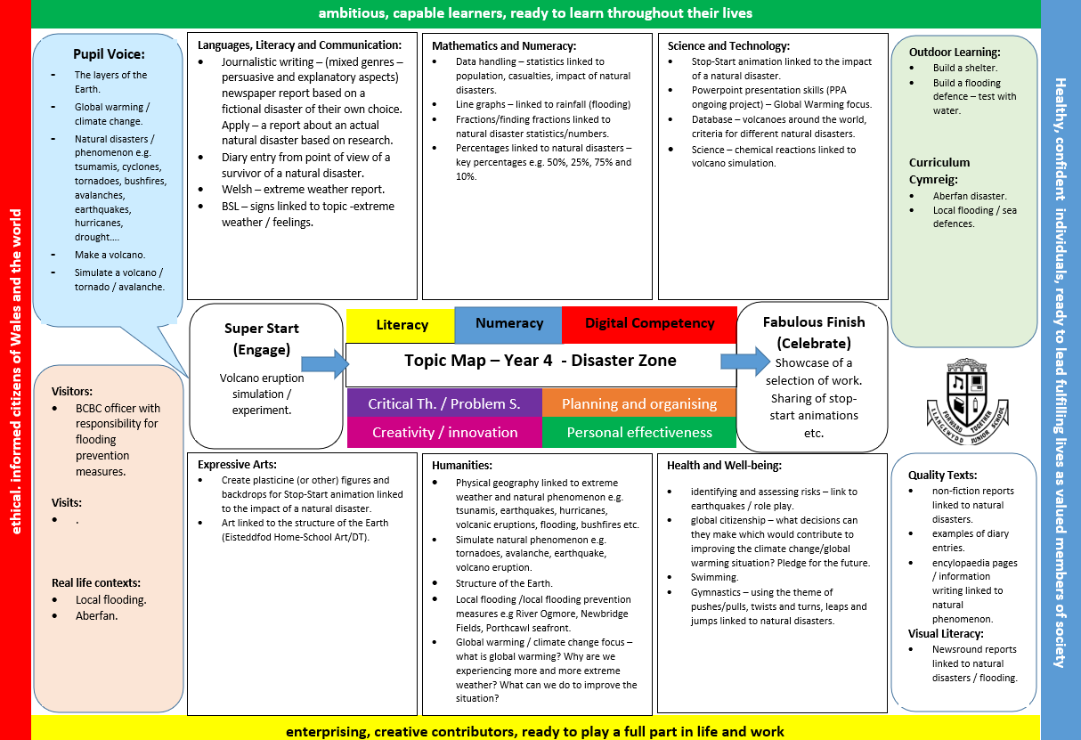

Appendix 2 – Our Curriculum for Wales Model
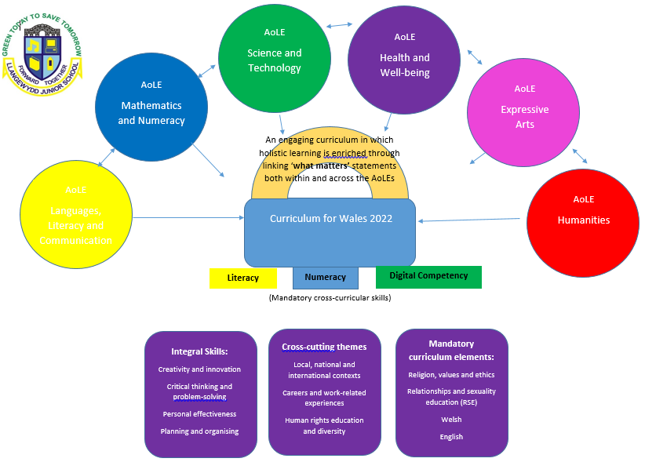

Appendix 3 – An example of a Topic Yearly Overview
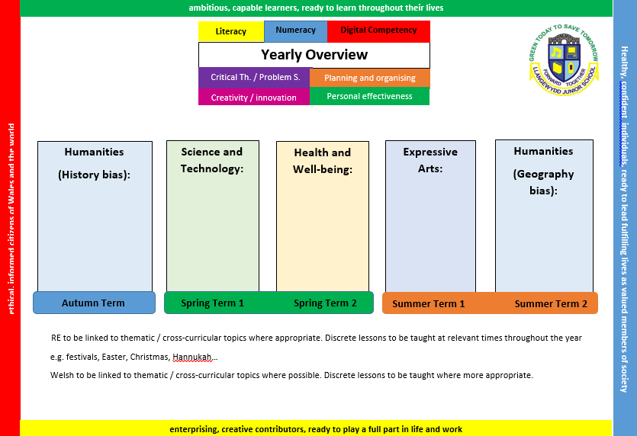

Appendix 4 – A sample from our Weekly Lesson Planning Template
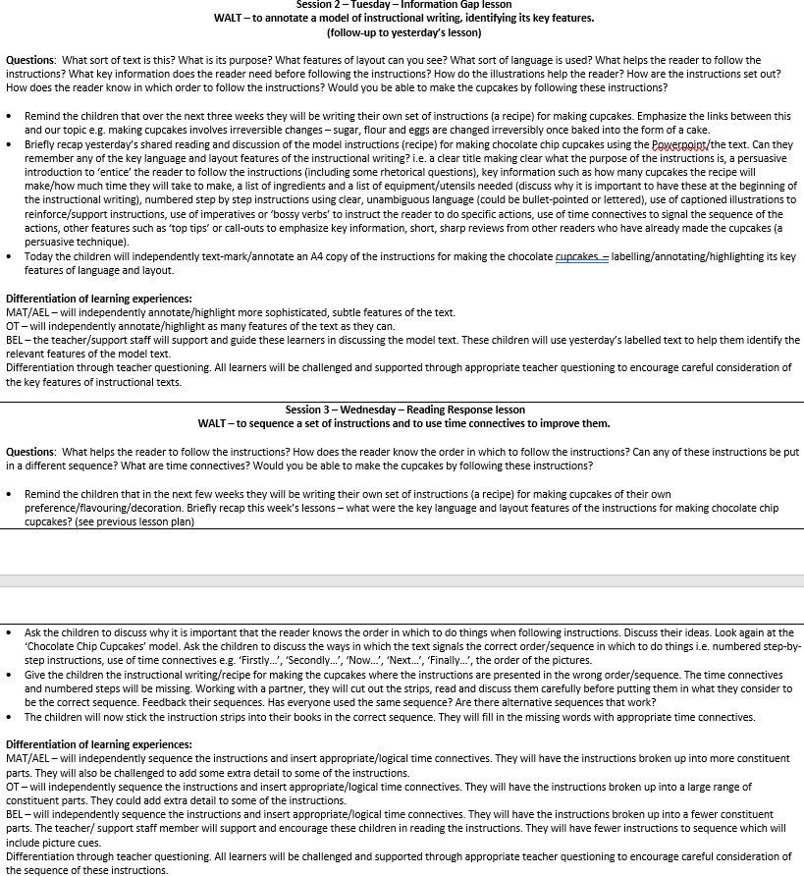

Appendix 5a – Pupil Entitlement – Learning Environment (Areas/Zones)
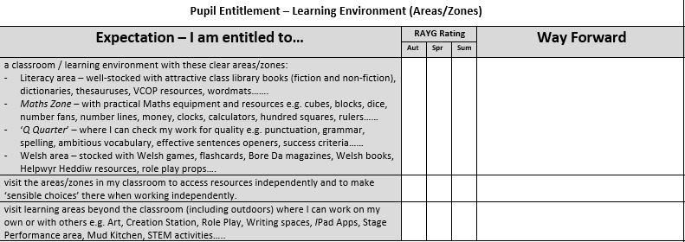

Appendix 5b – Pupil Entitlement – Learning Environment (Display)
