**Llangewydd Junior School – Ysgol Iau Llangewydd**

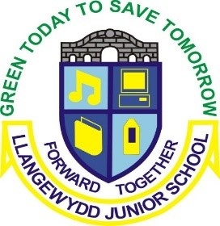



**Sunshine & Rainbow - What will we be learning about this term?**

Our topic this half term is ‘Dragons & Castles’. We hope to cover as much of the content, skills and experiences shown below as possible but this may change as Pupil Voice leads our learning into other areas.

**Science and Technology**

**Mathematics and Numeracy**

**Languages, Literacy and Communication**

* Electricity – make a circuit
* Build a ‘tardis’ with lights
* Make various foods from different countries
* **DCF –**
* Use Greenscreen to provide a voice over for where Ted is reporting from
* Powerpoint research into a chosen country
* Time, time zones, chronology
* Data collection on modes of transport to get to different countries
* Understanding and comparing temperatures
* Measure – Measuring the distance between cities etc

**Spring Term 2 2025**

**Sunshine & Rainbow**

**Toy Time Travel**

* Discussion on likes and dislikes of different countries/periods
* Write a report of a country/period that has been visited by Ted
* Research famous travellers – Neil Armstrong, James Cook, Christopher Columbus
* Listen to and read a range of stories about other countries
* **Welsh** – Read Tedi Twt books

**Health and Well-being**

**Humanities**

Our **Four Purposes** inform all our learning:

* ambitious, capable learners
* enterprising, creative contributors
* ethical, informed citizens
* healthy, confident individuals

Cross-curricular Responsibilities inform all our learning:

**Literacy, Numeracy and**

**Digital Competency**

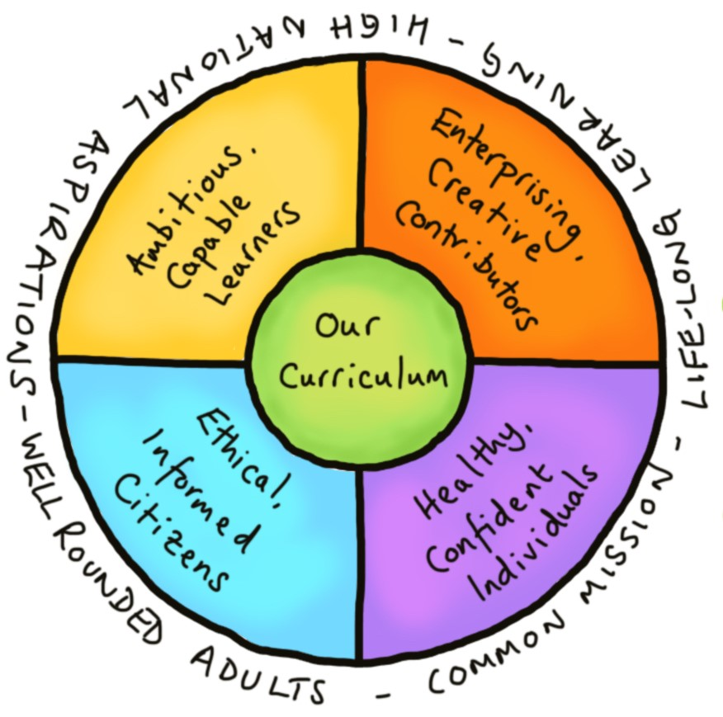

**Expressive Arts**

* Learn a dance from another country
* Use instruments to accompany dance
* Line drawings of houses in different countries/periods
* Make a toy and dress in National costume
* Design and build a ‘tardis’ fit to take you into the future
* Resolving problems – discuss whether battle was necessary and other ways conflict could be resolved.
* Staying safe with electricity
* **RVE** – Christianity -Easter Story,

Ramadan

* **Outdoor activities** – Build a mode of transport to take you to the future!!
* Plan a journey
* Comparing past and present toys
* Comparing countries – climate, size etc
* Research & create a travel log on a country
* Map work to locate countiries and features
* Features and landmarks of different countries





* Listen to your child reading regularly for short, sharp periods of time (avoid making reading a chore) – their Bug Club book but also real-life texts e.g. menus, leaflets, adverts…
* Support your child with any homework tasks set by their teacher.
* Help your child to learn their times tables – Revisit the x2, x5 and x10 times tables but also learn their target times table.
* Encourage your child to use at home any of the interventions they use at school i.e. Lexia (some children), Reading Eggs , Mathseeds (some children) and Mathletics (some children).
* Join/visit your local library.
* Discuss the time in your everyday lives on analogue and digital clocks.
* Ensure that your child does activities that support their well-being e.g. eating well, sleeping well, resting well.
* Spend quality time with your child simply talking to them, enjoying family experiences, playing games…



* Let us know what they would like to learn about within the topic.
* Complete any homework tasks set by their teacher.
* Bring into school any interesting items linked to our topic.
* Read regularly – their Bug Club book, real-life texts e.g. menus, leaflets, adverts…
* Practise their times tables – Revisit the x2, x5 and x10 times tables but also learn their target times table.
* Spend some time at home using any of the interventions they use at school i.e. Lexia, Reading Eggs and Mathletics (some children)or Mathseeds(some children).
* Practise handwriting – letter and number formation.
* Spend time outside playing.
* Do activities that support their well-being e.g. eat well, sleep well, rest well.

**What can I do to support my child’s learning?**

**What my child can do:**



A celebration of the work we have participated in during the term.

Visitors from other countries

Museum (TBC)

**Our Fabulous Finish celebration event:**

**Visitors and Visits:**